 [Translated from German to English - www.onlinedoctranslator.com](https://www.onlinedoctranslator.com/en/?utm_source=onlinedoctranslator&utm_medium=docx&utm_campaign=attribution)

%iceFRUBUT

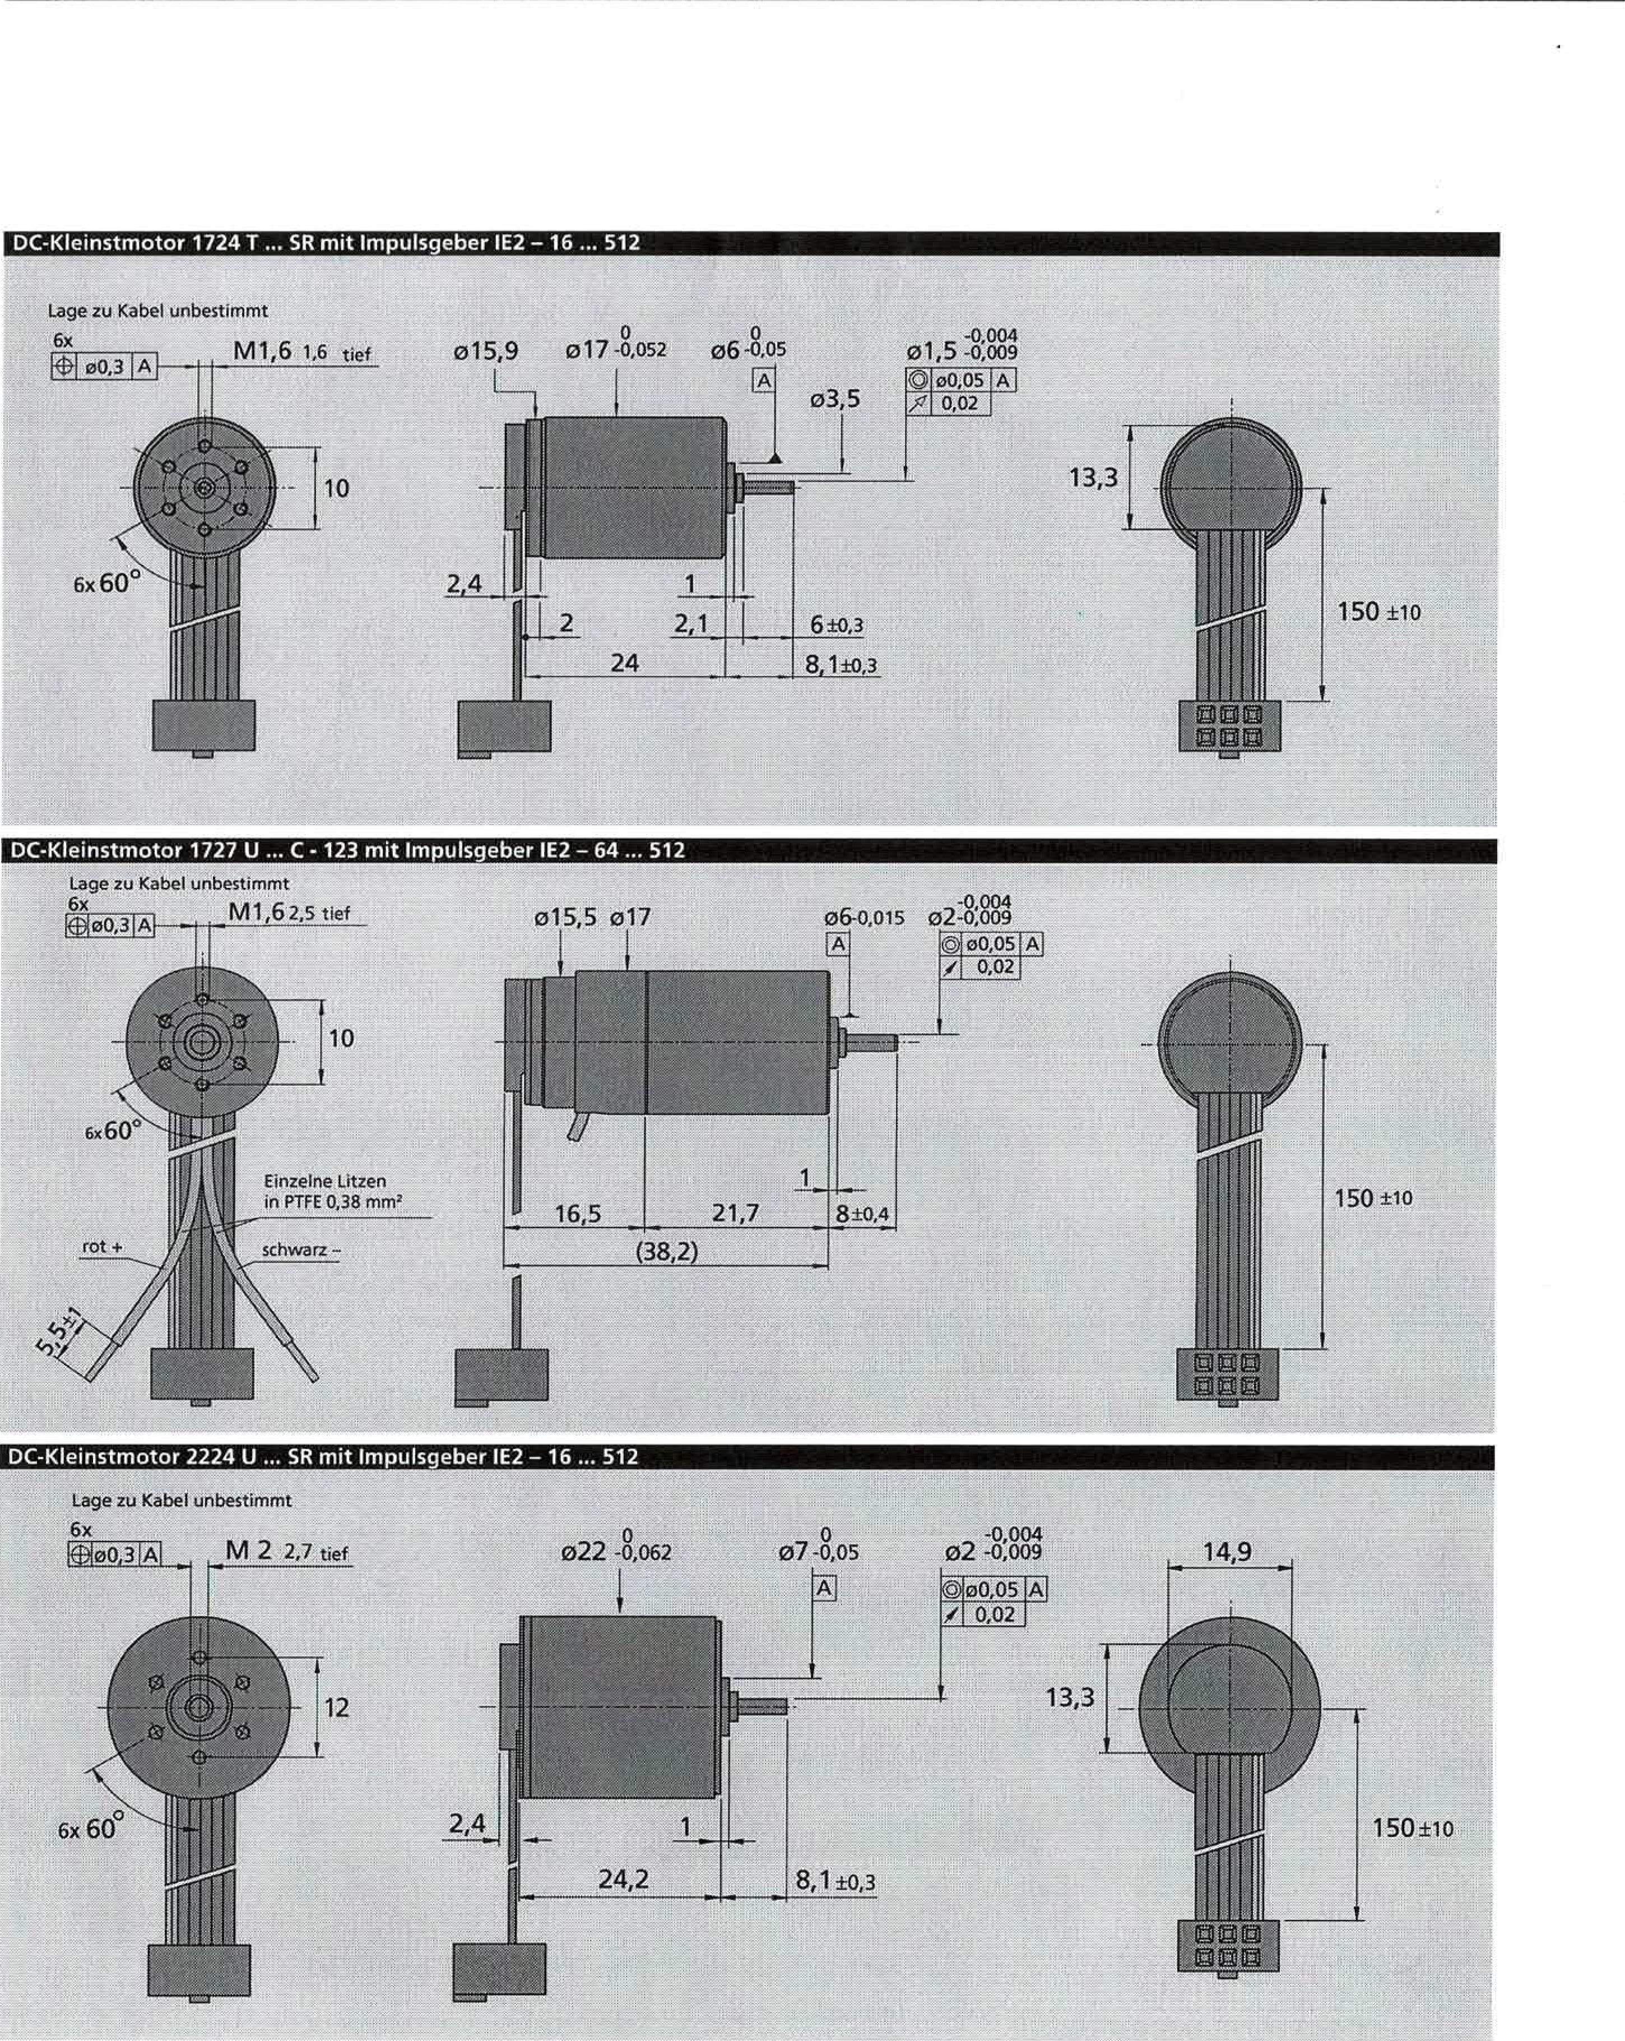

03.5

13.3

6±0.3

8.1±0.3

150 ±10

-0.004

01.5-0.009

0 o 0, 0 5*A*0.02I

Location to cable1unspecified

6x

12

**DC micromotor 1724 T ... SR with pulse • encoder 1E2 - 16 ... 512**

**DC micromotor 1727 UC - 123 with Inv • uls • eber 1E2 - 64 ... 512**

**DC-Screwdriver 2224 U ... SR with•Ws • boar 1E2 - 16 ... 512**

Position to cable undetermined

6x

RR00,31AF Wed'62'5 fief

150 ±

0

-0.004

06-0.015 02-0.009

©100.05 /1 0.02

015.5 017

10

•

6x60°

1111[black-

Individual strands in PTFE 0.38 rm2

Location to Kabef undetermined

6x

M22.7 deep

07-0.05

-0.004

02 -0.009

022-0.062

00.05

0.02

Al

13.3

2.4

24.2

8.1±0.3

150±10

Information aboutWarranty and lifetime as well as other Subject to change.

For technical explanations, see "Technical Information".

Issue 1.09.2003 [www.faulhaber.com](http://www.faulhaber.com)

FA HA R

**DC micromotor 1516 T SR with pulse generator 1E2 -16 ... 512**

Information on warranty and service life as well as other Subject to change.

For technical explanations see “Technical Information”.

Issue 1.09.2003 [**www.faulhaber.com**](http://www.faulhaber.com)

**DC micromotor 1524 T SR with 1m uls•boar 1E2 - 16 ... 512**

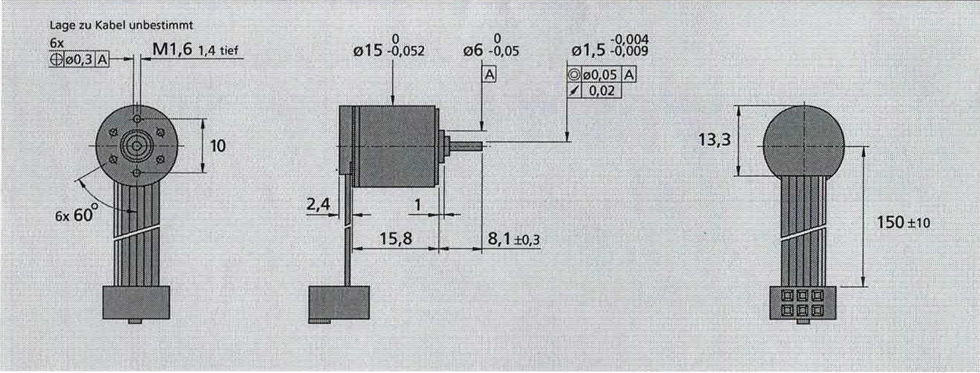

0

015 -0.052

0

06 -0.05

150 ±10

1

13.3

Position to cable undetermined

6x

M1.61.4 deep

10

-0.004

01.5 -0.009

000 05 Ai

0.02

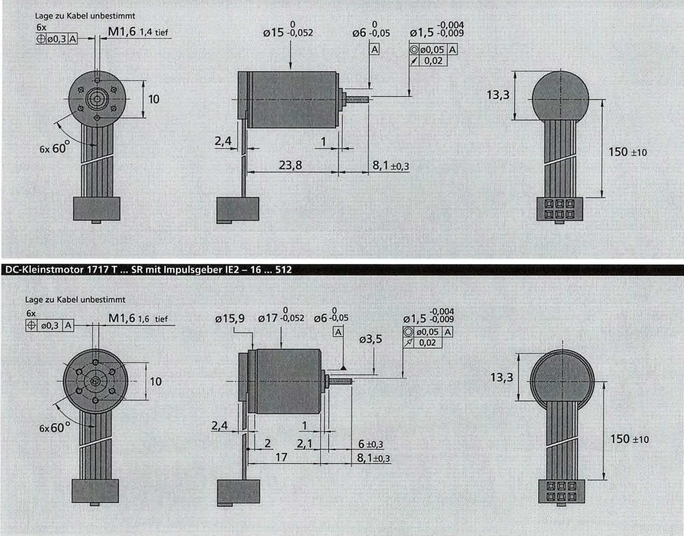

01.5:8:8g1

015.9 017-0.052 06.0.05

Position to cable unobstructed

6x

M1.61.6 deep

Ai

10

00.05

0.02

13.3

150 -±10

t.

10

2.4

0 -0.004

06-0.05 01.5-0.009

A

015-0.052

13.3

150 1-io

8.1±0.3

23.8

Position to cable undetermined

6x

M1.61.4deep

**DC initial motor 1717 T ... SR with 1m • uls• eber 1E2 - 16 ... 512**

**Christiani**

11111111111.11111111111111111111111111.11

**Technical in5litute for  
Aug-endContinuing education**

**Data sheet converter unit**

**Technical data**

|  |  |  |
| --- | --- | --- |
| **Designation** | **Abbreviation** | **Value** |
| **Supply*Voltage** | **Ue** | **24Vdc** |
| **1 / Mass** | **0Vdc** |
| **Ausgariisipenntini)**  **Adjustable on front panel usingR9 _** | **Ua** | **5Vd, up to 17Vdc** |
| **Issue •** | **la** | **0 ... 50mA** |
| **Input Boliongle** | **E1 ... E4** | **0Vdc** |
| **5Vdc /12Vdc TTL / CMOS** |
| **Exit Kanaki . ,..** | **A1...A4** | **0Vdc**  **-** |
|  | **24VdC** |

**Pin assignment**

**UA Output voltage 5V .. 17V**

**1 Ground (GND)**

**E1..E4 Inputs 1..4**

**Inclusion ofUA**

**A1..A4 Outputs Al ..A4**

**MettO$o (GND)**

**UE Input voltage 24V**

**converter unit Version 1.4 as of April 17, 2004**

|  |  |  |
| --- | --- | --- |
|  | **LIA** | **E4** |
|  |  |  |
|  |  | **E3** |
| **- Engine -** | | |
| **+** | | |
| **t•___** | | |
| **UA** | | |
| **- PLC -** | | |
| **Al** | **A2** | **A3** |
| **UE** | **1** | **A4** |

**Christiani**

converter unit Version 1.4 on April 17, 2004

Technical Institute***lOr Aus-***and further training

**Data sheet converter unit**

|  |  |  |
| --- | --- | --- |
| **Christiani** | Converter unit finished module  Art. No. 56426 TTL/CMOS -->24V Sn.-No. 00100 | 1=1:121 converter unit  kit  iii•■••••••■Item No.: 56427  Technical Institute forTTL/CMOS -> 24VInitial and continuing educationSerial No.: 10100 |
|  |
| Tealin Institute for Education and Training |

The converter unit is a DIN rail-mounted module. The module can be mounted directly on a DIN rail without the need for additional mounting hardware. It is used to power a motor and transmit encoder signals to a PLC.

**Functional description:**

The converter unit is supplied with 24VdeAt the same time, the converter unit supplies the motor with its operating voltage. The motor is connected to a rotary encoder, whose signals are transmitted to the converter unit. In the converter unit, the encoder signals are converted to PLC-compatible levels. The PLC records the converted encoder signals and determines the travel distance or the number of revolutions of the motor.

The converter unit also serves to control the motor's speed. This is achieved by adjusting the motor's operating voltage using a rotary potentiometer.

**Features:**

The input voltage U supplies the entire converter unit. Ueis always 24VDC, The converter unit includes two separate functions:

Voltage conversion

The input voltage Ueis adjusted to U using an adjustable linear regulatoraThe output voltage Uacan be adjusted via a potentiometer. A voltage range between approximately 5Vd and 17Vd is possible.

The output voltage U controls the speed of the connected motor.

Level conversion

A driver module from Allegro (IC module2UDN2987A) serves as an interface for converting standard low-level logic signals to PLC-compatible signals. It uses TTL (5Vd,) and CMOS (12Vd,) Logic level in 24Vd, level conversion. With this level conversion, TTL signals can be connected to a programmable logic controller (PLC), for example.

Allnotused entrances (E1to E4) must be connected to ground.

The exits (A1to A4) of the converter unit are short-circuit-proof. In the event of a short-circuited output, switch off the converter unit or the entire system, then eliminate the short circuit, check the connections again, and then switch it back on. Outputs that were briefly short-circuited will only be reactivated after switching the converter unit off and on again.

**FAULHABER**

**Series 2224 SR**

|  |
| --- |
| 1 Nominal voltage  2 Connection resistance  3 Output power  4 Efficiency |

|  |
| --- |
| 5 Idle speed  6 No-load current (for shafts o 2.0 mm)  7 Stopping torque  8 Friction torque |

|  |
| --- |
| 9 Speed ​​constant  10 Generator voltage constant  11 Torque constant  12 Current constant |

13 Slope of the nM characteristic curve

14 Connection inductance

15 Mechanical start-up time constantAW

16 Rotor moment of inertia

17 Angular acceleration111111111.116

|  |
| --- |
| 18 thermal resistors  19 Thermal time constant  20 Operating temperature range:   * Motor * Rotor, max. permissible |

|  |
| --- |
| 21 Shaft bearings  22 Shaft load, max. permissible:  - for shaft diameter   * radial at 3000 rpm (3 mm from bearing) - axial at 3000 rpm * axially at standstill   23 Wave play:  - radial  - axial |

24 Housing material

25 weight

26 Direction of rotation

**DC micromotors**

Precious metal commutation

|  |  |  |  |
| --- | --- | --- | --- |
|  | 3  0.56 3.9280  8 100 0.066 | 6  1.94 4.55 82  ' 8,200  0.029 | 12  8.71 4.05 82  7,800 0.014 |
| Ur,R  P2 max  **11**max.  noI. |
| MH | 18.5 | 121.2 | 19.8 |
| MR | 0.23 | 0.2 | 0.2 |
| kr, | 2,730 | 1,380; 0.725 | 657  1,520 |
| n/a | - 0.366 |
| km | 3.49 | 6.92 | 14.50 |
| lc, | 0.286 | 0.144 | 0.069 |
| On/AM | 438 | 387 | 394 |
| L | 11 | 45 | 200 |
| TIll | 11 | i11 | 11 |
| J | 2.4 | 2.7 | 2.7 |
| LA max. | 77 | 178 | , 74 |
| Rth /Ruiz | 5 / 20 |  |  |
| -rwl/Twz | 6.8/440 |  |  |

**5 mNos**

Can be combined with

Gearbox:

20/1, 22E, 22/2, 22/5, 22/6, 23/1, 38/3 Pulse generator:

1E2

18 ---/36 volt

117.50 36.30 91.40 f2

4.54 3.88 3.46 W

82 81 80 %

18,100 7,800 7,800 rpm

0.010 0.007 0.005 A

21.4 19.0 16.9 mNm

0.21 0.2 0.22 mNm

454 328 219 rpmN

2,200 3,040 4,560 mV/rpm

21.00 29.10 43.50 mNm/A

0.048 0.034 10,023 A/mNm

379 411 ' 462 rpm/mNm

450 800 1,800 !_tH

11 i11 . 11 ms

2.8 2.6 2.3 gcm2

; 77 . 74 174 -103 rad/s2

KNV

- 30 ... + 85 (special version - 55 + 125) 'C

+125 'C

Sintered bearings ball bearings j Ball bearing, preloaded

(standard) (special version) (special version)

2.0 , 2.0 2.0 mm

1.5 8 8 N

0.2 0.8 0.8 N

20 10 10 N

s 0.03 0.015 0.015 mm

s 0.2 . 0.2 0 mm

Steel, black coated

46

clockwise viewed on output shaft

Recommended values

27 speed up to

28 Continuous torque up to

29 Thermally permissible continuous current

|  |  |  |  |  |  |  |  |
| --- | --- | --- | --- | --- | --- | --- | --- |
| ne max_ | 8,000 | 8,000 | 8,000 | 8,000 | 8,000 | 8,000 | rpm |
| Me max. | 5 | 5 | 5 | 5 | 5 | 5 | mNm |
| theIII.. | 2,200 | 1,200 | 0.570 | 0.400 | 0.280 | 0.180 | A |

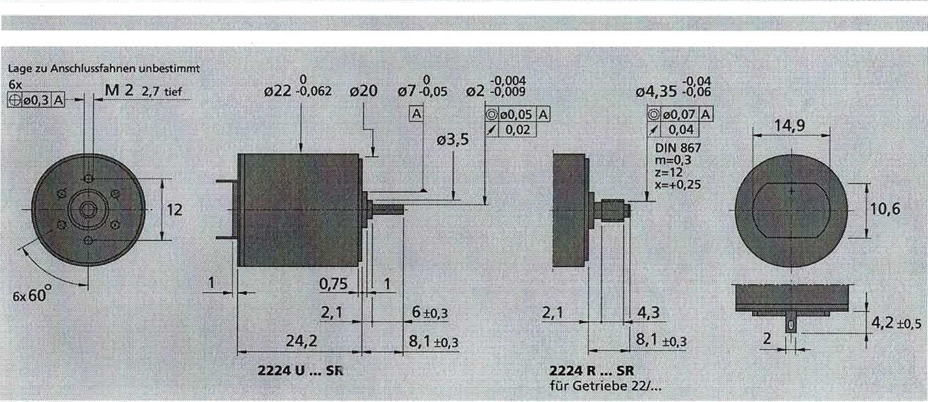

0

022-0.062

0.75

2.1

24.2

**2224 U**

-0.04

04.35-o,o6

e0.07

0.04

DIN 867 m=0.3 z=.12 x=+0.25

4.2 ± 0.5

14.9__.

**2.1 4.3**

J**8.1**±0.3

**2224 R ... SR**

for gearbox 22/...

-0.004

OZ

No0.05 Al  
0.02

Position to connecting lugs undetermined

6±0.3

8.1±0.3

Information on warranty and service life as well as other **Special versions for DC micromotors are on page**62**visible.**

For technical explanations, see “Technical Information”. **Subject to change,**

50 [**www.faulhaber.com**](http://www.faulhaber.com)

**FAULHABER**

**110**

[www.faulhaber.com](http://www.faulhaber.com)

|  |  |  |  |
| --- | --- | --- | --- |
| **Nano gear** |  | **0.6 Nm** |  |
|  |  |

|  |  |  |  |
| --- | --- | --- | --- |
|  |  | **Can be combined with**DC micromotors:  2224, 2230, 2233  DC motor-tacho combinations:2251 | |
| **Series 22E** |  |
|  | 22E | **22EC** | **22EK** |
| Housing material  Gear material  Max. recommended input speed for: | plastic plastic | plastic plastic | plastic plastic |
| - Continuous operation | 5000 rpm | 5000 rpm | 5000 rpengummom- |
| Gear backlash, unloaded | 53' | s | ,3 |
| Output shaft bearing | Sintered bearings | Ceramic bearings | Ball bearing MUME11 |
| Maximum permissible shaft load: |  |  |  |
| - radial (5 mm from the mounting flange) | s 3 N | s 15 N | s 50 N |
| - axial | s 3 N | s 2 N | s 5N |
| Maximum pressing force | s15 N | s 15 N | s 15N |
| Bearing clearance (measured at the bearing): |  |  |  |
| - radial | s 0.03 mm | s 0.03 mm | s 0.015 mm |
| - axial | s 0.25 mm | s 0.25 mm | s 0.25 mm |
| Operating temperature range | 30 ... + 65 'C | -20 ... +85 °C | -30 ... +85 °C |

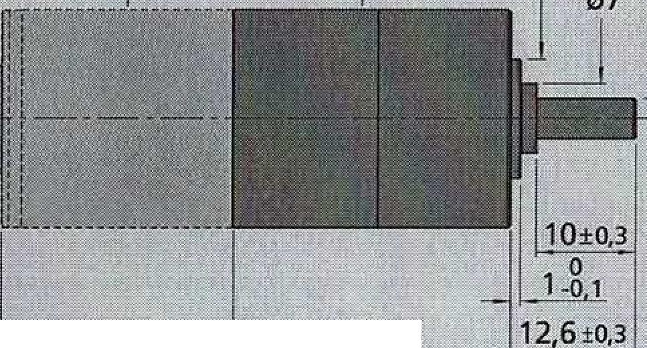Information on warranty and service life as well as further Subject to change.

|  |  |  |  |  |  |  |  |  |
| --- | --- | --- | --- | --- | --- | --- | --- | --- |
| **Technical data** | |  |  |  |  |  |  |  |
|  | | Long with engine | |  | torque | |  |  |
| Reduction Order Number Weight Long | |  | |  | Duration- | Short-term | Direction of rotation | Effectiveness |
| relationship Code for transmission without without 2224  (nominal) Engine I) levels Motor Motor 1) | | 2230 1) | 2233 1) | 2251  1) | operation | operation | the wave | degree |
| L2 Li | | L1 | L1 | L1 | M max. | M max. |  |  |
| 9 mm mm | | mm | mm | mm | mNm | mNm |  |  |
| 19:1 B 2 17 27.8 51.3 | | 57.1 | 59.7 | 78.7 | 200 | 400 |  | 78 |
| 28:1 A 2 17 27.8 51.3 | | 57.1 | 59.7 | 78.7 | 200 | 400 |  | 77 |
| B 3 19 32.8 56.3 | | 62.1 | 64.7 | 83.7 | 300 | 600 |  | 69 |
| C102.:12) A 3 19 32.8 56.3 | | 62.1 | 64.7 | 83.7 | 300 | 600 |  | 68 |
| 152 :1 A 3 19 32.8 56.3 | | 62.1 | 64.7 | 83.7 | 400 | 800 |  | 67 |
| 249 :1 B 4 20 37.8 61.3 | | 67.1 | 69.7 | 88.7 | 400 | 800 |  | 62 |
| 369 :1 A 4 20 37.8 61.3 | | 67.1 | 69.7 | 88.7 | 500 | 1,000 |  | 61 |
| 546 :1 A 4 20 37.8 61.3 | | 67.1 | 69.7 | 88.7 | 600 | 1,000 |  | 60 |
| 809 :1 A 4 20 37.8 61.3 | | 67.1 | 69.7 | 88.7 | 600 | 1,000 |  | 59 |
| 896 :1 B 5 22 42.8 66.3 | | 72.1 | 74.7 | 93.7 | 600 | 1,000 |  | 55 |
| 1,327:1 A 5 22 42.8 66.3 | | 72.1 | 74.7 | 93.7 | 600 | 1,000 |  | 54 |
| 1,966:1 A 5 22 42.8 66.3 | | 72.1 | 74.7 | 93.7 | 600 | 1000 |  | 53 |
| 2,913:1 A 5 22 42.8 66.3 | | 72.1 | 74.7 | 93.7 | 600 | 1,000 |  | 52 |
| 3,225:1 B 6 24 47.8 71.3 | | 77.1 | 79.7 | 98.7 | 600 | 1,000 |  | 49 |
| 4,315:1 A 5 22 42.8 66.3 | | 72.1 | 74.7 | 93.7 | 600 | 1,000 |  | 51 |
| 4,778:1 A 6 24 47.8 | 71.3 | 77.1 | 79.7 | 98.7 | 600 | 1,000 | = | 48 |
| 7,078:1 A 6 24 47.8 | 71.3 | 77.1 | 79.7 | 98.7 | 600 | 1,000 | = | 47 |
| 10,486:1 A 6 24 47.8 | 71.3 | 77.1 | 79.7 | 98.7 | 600 | 1,000 |  | 46 |
| 15,534:1 A 6 24 47.8 71.3 | | 77.1 | 79.7 | 98.7 | 600 | 1,000 | = | 46 |
| 23 014 :1 A 6 24 47.8 71.3 | | 77.1 | 79.7 | 98.7 | 600 | 1 000:y | national team | 46 |
|  | |  |  |  |  |  |  |  |
| e.g. order description: | |  |  |  |  |  |  |  |
| 2224 B 012 SR + 22E 19:1 | |  |  |  |  |  |  |  |
| These gearboxes are only available assembled with motors. | |  |  |  |  |  |  |  |
| Location toConnection lugs | | (2251) |  |  |  |  |  |  |
| rindefinite | | (2233) |  |  |  |  |  |  |
| 3x | | (2230) |  | 0 | 0 | -0.005 |  |  |
| [M34deep022(2224)- | | |  | 022-0.3 | 012-0.05 | 04 -0.012 |  |  |

f

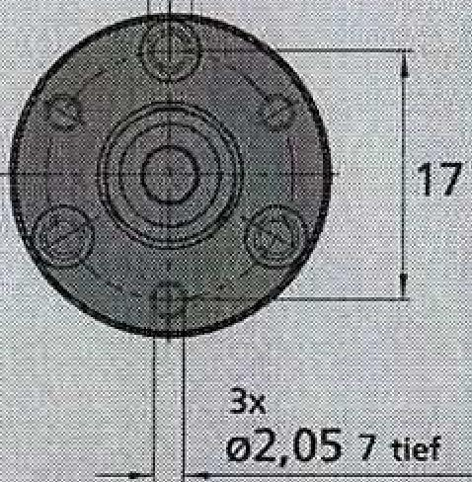

L2±0.5

1.1 ±0.8

**22E, 22EC, 22EK**

For technical explanations, see “Technical Information”.

**FAULHABER**

|  |  |  |  |  |
| --- | --- | --- | --- | --- |
| **Initiator**  Magnetic pulse generators |  |  |  |  |
|  |  | Special features:  16 pulses per revolution2 outputs  Digital output | |
|  |  |  |  |  |

**Series 1E2 - 16**

**1E2 - 16**

|  |
| --- |
| Impulses per revolution  Output signal, rectangular  Operating voltage  Rated current consumption, minimum value (V**DD =**12 V DC) Output current, max. permissible  Pulse width4  Signal phase shift, channel A to 821Signal rise/fall time, max. (CLoAD = 100 pF) Frequency range ", up to  Moment of inertia of the pulse disc Operating temperature range |

10,11

25 ... +85

|  |  |
| --- | --- |
| N | 16 |
|  | .2 |
| **V DD** | 4 .. 18 |
| **I CD** | ' typically 6, max. 12 |
| **I**our | 15 |
| P | 180 ± 45, |
| (1) | 90 ± 45 |
| WHERE: | 2.5 / 0.3 |
|  | 7 |

lOutput V DC

mA mA.21= Qe

ce

**PS•:.**

;kHz

Speed ​​(rpm) = f (Hz) x 601N z> tested at 2 kHz

41 41

**Ordering instructions**

**Initiator** Output impulses **- combined with DC micromotors**

per revolution 41

1E2 16 2 16- Series 1516 ... SR

For information on warranty and service life as well as further technical explanations, see "Technical Information".

Issue 1.09.2003

Subject to change.

[**www.faulhaber.com**](http://www.faulhaber.com)

1E2-16 2 16 Series 1524 ... SR

1E2-16 2 16 Series 1717 ... SR

1E2 - 16 2 16 Series 1724 ... SR

1E2 - 16 2 16 Series 2224 ... SR

|  |
| --- |
| 'Surgery |
| cf. |

**Special features**

**Output signals / circuit diagram / connector information**

These incremental pulse generators, in conjunction with FAULHABER DC micromotors, are suitable-NI-the monitoring and control of speed and direction of rotation as well as for the positioning of the drive shaft.

The pulse generator is integrated into the SR series DC micro motor and extends it by only 1.4 mm!

The use of Hall sensors and a multi-part magnetic ring results in two channels that are 90° out of phase.

The supply voltage for the pulse generator and the DC micro­motor and the output signals are connected via a ribbon cable with a connector.

The data for the DC micromotors and the corresponding gearboxes can be found in the corresponding data sheets.

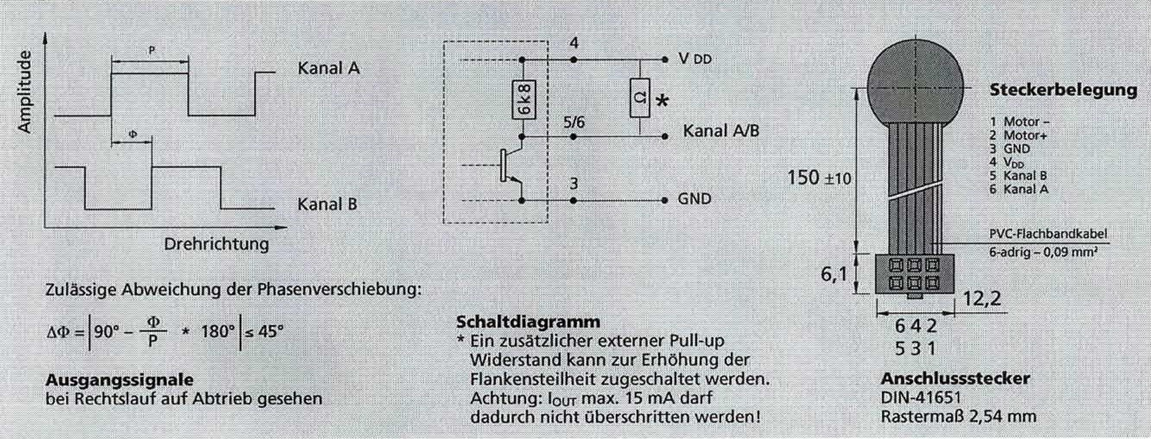

Channel A

**E**

Channel B

Direction of rotation

4

150 ±10

1 engine

2 engines.

3 GND

4 VDD

5 channel

6 Channel A

**Pin assignment**

PVC ribbon cable

6-core - 0.09 mm'

A(1)

90° - * 180°

s 45°

**Circuit diagram**

* An additional external pull-up resistor can be added to increase the edge steepness. Caution: OUT max. 15 mA maythrough thisnot be exceeded!

-_12,2

642   
53 1

**connector plug**DIN-41651 pitch 2.54 mm

Permissible deviation of the phase shift:

**Output signals**

when running clockwise, seen on output

Technical documentation Handling device

58 © by Dr.-Ing. Paul Christiani GmbH & Co. KG

|  |
| --- |
| **Step: 4 Function: Suction cup on** |
| **Comment:**Negative pressure |
| **Betting conditions:**Step 3  **AND**  B2 |
| **Reset conditions:**Step 5  or  Error collector |
| **Actions: Vacuum cleaner on/Start waiting time T1** |

|  |
| --- |
| **Step: 5 Function: Open cylinder** |
| **Comment:**Move up the Y-axis |
| **Betting conditions:**Step 4  AND  Ti |
| **Reset conditions:**Step 6  or  Error collector |
| **Actions: Open cylinder** |

|  |
| --- |
| **Step: 6 Function: Retract cylinder** |
| **Comment:**Retract Z-axis |
| **Betting conditions:**Step 5  AND  B3 |
| **Betting conditions:**Step 7  or  Error collector |
| **Actions: Retract cylinder** |

Handling device Technical documentation

0 by Dr.-Ing. Paul Christiani GmbH & Co. KG 59

|  |
| --- |
| Step:**T Function: Rotate to storage position.** |
| **Comment:**Rotate X-axis |
| **Betting conditions:**Step 6  AND  B4 |
| **Reset conditions:**Step 8  or  Error collector |
| **Actions: Rotate to storage position.** |

|  |
| --- |
| **Step: 8 Function: Lower cylinder** |
| **Comment:**Lower Y-axis |
| **Betting conditions:**  Step 7  AND  Storage position reached: Target/actual comparison (encoder value) |
| **Reset conditions:**Step 9  or  Error collector |
| **Actions: Lower cylinder** |

|  |
| --- |
| Step:**9 Function: Vacuum cleaner off** |
| **Comment:**Negative pressure from |
| **Betting conditions:**Step 8  AND  B2 |
| **Reset conditions:**Step 10  or  Error collector |
| **Actions: Vacuum cleaner off/Start waiting time T2** |

**Technical documentation Handling device**

60 © byDr.-Ing. Paul Christiani GmbH & Co. KG

|  |
| --- |
| **Step: 10 Function: Open cylinder** |
| **Comment:**Move up the Y-axis |
| **Betting conditions:**Step 9  AND  T2 |
| **Flocking conditions:**Step 11  or  Error collection |
| **Actions: Open cylinder** |

|  |
| --- |
| **Step: 11 Function: Open cylinder** |
| **Comment:**Rotate X-axis |
| **Betting conditions:**Step 10  AND  B3 |
| **Reset conditions:**Step 12  or  Error collector |
| **Actions: Rotate to recording position.** |

|  |
| --- |
| **Step: 12 1Function: Chain end** |
| **Comment:**  This step becomes active when rotation to the recording position is complete. No action is performed. |
| **Betting conditions:**  Step 11  AND  Recording position reached: Target/actual comparison (encoder value) |
| **Ticket setting conditions:**Step 2  or  Error collector |
| **Actions: none** |

**5. Commissioning instructions**

Handling device Technical documentation

© by Dr-Ing. Paul Christiani GmbH & Co. KG

61

***Condition***

***Visual inspection***

|  |  |
| --- | --- |
| Arrangement of components according to plan |  |
| Arrangement of wiring and tubing |  |
| Alignment of the components to each other |  |
| Labeling of components (readable from the front or from the right) |  |
| Cleanliness (no stripping residue in the grooves etc.) |  |
| Scratch-free surfaces |  |

***Checking mechanical connections***

Strength of the assembled parts

Strength of the end brackets on the DIN rail

Tight fit of the valve island

Firm fit of sensor B1

Precise alignment of cylinder 34053141 with Al profile 36100179

***Checking pneumatic connections***

|  |
| --- |
| Compressed air hoses firmly connected  Compressed air hoses laid with sufficient bending radius Compressed air connectors have sufficient hold |

***Checking electrical connections***

|  |  |
| --- | --- |
| Wire end necks pressed correctly |  |
| Wires correctly inserted into terminals and firmly screwed or clamped |  |
| Clamping bridges firmly screwed, no protruding cutting residues |  |
| Relay inserts are plugged in, FOBe not bent |  |

***Mechanical functional test***

|  |  |
| --- | --- |
| Cylinders can be moved to all end positions |  |
| The anti-twist device on the vacuum cleaner works |  |
| Rotation of the arm by 200° possible without resistance from hoses/pipes |  |
| Spring return suction cup works perfectly |  |

***Pneumatic functional test***

|  |  |
| --- | --- |
| Make sure the pneumatic system is closed. |  |
| Set the supply air pressure to 4 bar. |  |
| Establish the compressed air connection. |  |
| Check for leaks. |  |
| Check that the solenoid valves function correctly according to the circuit diagram. |  |
| To do this, operate the manual triggers on the solenoid valves Y1, Y2 and Y3. |  |
| Operating Y1 means lifting the vertical cylinder. |  |
| Pressing Y2 means suction on. |  |
| Pressing Y3 means extending the Z axis. |  |

Technical documentation Handling device

***Condition***

***Electrical functional test***

Controlling 24V at terminal X1 0.3 must start the motor in clockwise rotation. Controlling 24V at terminal X1 0.4 must start the motor in anticlockwise rotation.

Check the function of solenoid valves Y1, Y2 and Y3.

Controlling 24V at terminal X1 0.0 should raise the vertical cylinder. Controlling 24V at terminal X1 0.1 should activate the suction cup.

Controlling 24V at terminal X1 0.2 must allow the Z-axis to extend.

Check the function of the rotary encoder as follows.

Remove the relay inserts from K1 and K2. Move the arm of the handling device very slowly by hand.

A voltage must be applied alternately to terminals X0.5 and X0.6  
of 24V and 0V can be measured.

Check the function of sensor B5.

Measuring 24V at terminal X2 0.4 means: Z-axis extended

Check the function of sensor B4.

Measuring 24V at terminal X2 0.3 means: Z-axis retracted

Check the function of sensor B3.

Measuring 24V at terminal X2 0.2 means: vertical cylinder up

Check the function of sensor B2.

Measuring 24V at terminal X2 0.1 means: vertical cylinder down

Connect the 24 V DC power supply and the ground connection. Check the function of sensor B1.

Measuring 24V at terminal X2 0.0 means: Home position

Without connecting the power supply:

Perform continuity test between "+" and "-". If continuity is found: eliminate the short circuit!

Self-checking of the correct polarity for the following non-short-circuit-proof components: Reed switches B2, B3, B4, B5 and encoder connection.

|  |  |
| --- | --- |
| Carried out | Place, date, signature |

62

© by Dr.-Ing. Pau! Christiani GmbH & Co. KG

4.5 Function plan HHZA automatic

Technical documentation Handling device

Continuation conditions (transitions)

Chain end  
Basic €€€ung

Car - Irnpuls

Steps Actions

Step 9

Command€ removal car started

Argument 12

Step2

Extend cylinder

Cylinder is ~

extended

Step 3

Lower cylinder

LZylinthe1st lowered!

|  |  |  |
| --- | --- | --- |
|  |  | S Vacuum cleaner  S Start waiting time Tt |
|  |
|  |  |

Waiting times  
expired TI

$ Open cylinder I

Cylinder 1st opened

Step S

Step6

Retract cylinder

T

52 © by Dr.-Ing. Pau[ Christiani GmbH & Co. KG

Step 7

Storage position reached

Handling device

Technical documentation

|  |  |  |  |  |  |  |
| --- | --- | --- | --- | --- | --- | --- |
|  |  |  |  |  |  |  |
| Cylinder is retracted |  |  |  |  |  |
|  |  |  |  |  |
|  |  |  |  |  |  |
|  |  |  |  | S | Turn to storage position |
|  |  |  |  |
|  |  |  |  |  |  |

Step 8

S Lower cylinder

Cylinder is lowered

Step 9

|  |  |
| --- | --- |
| S | Vacuum cleaner off |
| S | Waiting time starters T2 |

Waiting time T2 has expired

Step 10

S Open cylinder

0 by Dr.-Ing. Paul Christiani GmbH & Co. KG 53

Step 11

Cylinder is opened

Recording position reached

Turn to recording position

S

Step 12

■

Step 2

**4.6 Program steps for home position travel**

Handling device Technical documentation

0 by Dr.-Ing. Paul Christiani GmbH & Co. KG 55

|  |
| --- |
| **Step: 1 Function: Basic position** |
| **Comment:**  In this step, the HHZA is moved to the home position by an initialization signal.  Requirement: Z-axis is between storage position and home position.  In order for the counter to be enabled, the SW-Gate input on SFB 47 must be set to signal '1'. |
| **Betting conditions:**  Signal operating mode Automatic (Impulsy |
| **Reset conditions:**  Step 2 •  or  Error collector |
| **Actions:**no |

|  |
| --- |
| **Step: 2 Function: Open cylinder** |
| **Comment:**Move up the Y-axis |
| **Betting conditions:**  (Step 1 or 6) AND automatic started AND start pulse |
| **Reset conditions:**Step**3**  or  Error collector |
| **Actions: Open cylinder** |

|  |
| --- |
| **Step: 3 Function: Turn left to home position.** |
| **Comment:**Rotate X-axis |
| **Betting conditions:**Step 2  AND  **B3** |
| **Reset conditions:**Step 4  or  Error collector |
| **Actions: Turn left to home position.** |

Technical documentation Handling device

56 ©by Dr.-Ing. Paul Christiani GrnbH & Co. KG

|  |
| --- |
| **Step: 4 Function: Set encoder reference value** |
| **Comment:**  The encoder is set to the number value that refers to the home position. |
| **Betting conditions:**Step 3  AND  B1 |
| **Flocking conditions:**Step 5  or  Error collector |
| **Actions: Set encoder reference value AND Start wait time Ti** |

|  |
| --- |
| **Step: 5 Function: Turn left to recording position.** |
| **Comment:**Rotate X-axis |
| **Betting conditions:**  Step 4  AND T1  AND  Encoder reference value C adopted |
| **Reset conditions:**Step 6  or  Error collector |
| **Actions: Turn left to recording position.** |

|  |
| --- |
| **Step: 6 Function: Chain end** |
| **Comment:**  This step becomes active when rotation to the recording position is complete. No action is performed.  With step**At the end of the chain, HHZA is in its basic position. This step ' Chains­End ' serves as the entry condition of the step chain HHZA.** |
| **Betting conditions:**  Step 5  AND  Recording position reached: Target/actual comparison (encoder value) |
| **Risk setting conditions:**Step 2  or  Error collector |
| **Actions: None** |

**4.7 Program steps for automatic operation**

Handling device Technical documentation

0 by Dr.-Ing. Paul Christiani GmbH & Co. KG 57

|  |
| --- |
| **Step:i IFunction: Wait for home position** |
| **Comment:**  In this step, the basic position of the HHZA is examined. |
| **Betting conditions:**  Step 'Chain end' from home position travel HHZA-GS ' |
| **Reset conditions:**Step 2  or  Error collector |
| **Actions:**No |

|  |
| --- |
| **Step: 2 IFunction: Extend cylinder** |
| **Comment:**  Extend Z-axis to recording position. |
| **Setting conditions:**  (Step 1 or 12) AND Automatic started AND Befell' removal |
| **Rack setting conditions:**Step 3  or  Error collector |
| **Actions: Extend cylinder** |

|  |
| --- |
| **Step: 3 Function: Lower cylinder** |
| **Comment:**Lower Y-axis |
| **Betting conditions:**Step 2  AND  B5 |
| **Reset conditions:**Step 4  or  Error collector |
| **Actions: Lower cylinder** |

**4.3.2 Parameterization of the hardware in STEP?**

Technical documentation Handling device

46

© by Dr.-Ing. Paul Christiani GmbH & Co. KG

Calling up the parameterization masks requires that you have created a project­in which you can save the parameters.

1. Start the SIMATIC Manager and call the hardware configuration­ration in your project.
2. Double-click the Count submodule of your CPU. This will open the Properties dialog box.
3. Parameterize the submodule "Numbers" and exit the parameterization mask with*OK.*See details below.
4. Save your project in HW Config with*Station > Save and translate.*
5. Load the parameter data into the CPU in STOP mode with*Goal­system > Load into assembly....*The data is now located in the CPU's system data memory.
6. Perform a CPU restart.

Details on parameterization

Settings in the Properties dialog box of the Numbers submodule.

Channel: 0

Operating mode: Endless numbers

General tab: do not change

"Addresses" tab: do not change, use system defaults: inputs and outputs start at 768.

Tab "Basic parameters": do not change

Numbers tab: do not change

Note: To reverse the direction of payment if necessary, you can­Properties — Dialog in the tab "Numbers" check the entry "Number­direction inverted".

**4.3.3 Parameterization of the system function blockSFB47**

Handling device Technical documentation

CO by Dr.-ing. Paul Christiani GrnbH & Co. KG

47

For system function blocks(SFB)and system functions(SFC)These are pre-configured blocks that are integrated into an S7 CPU. They provide functions that can be called from the user program.­will be !Karmen.

The SFB 47 is located in the "Standard Library" under "System Function Blocks".

The SFB must be called cyclically. For a better overview, SFB47 is called in a function that is assigned to the handling device in the project. The use of OR, FB, and DB numbers must be adapted to the respective project. The following overview shows an example.­plarisch the call hierarchy.

OB1

- CALL FC30

FC30

- CALL SFB47, DB31

DB31 must be parameterized; it contains the input and output signals (in and out) important for the counter block SFB47.­The current numerical value is also included in the initial values, the use of which will be explained later.

To activate the counter, only three values ​​in DB31 must be observed. The following table shows an extract from DB31 in the data view. The values ​​for the module address "LADDR", the channel number "CHANNEL" and the "SW GATE" must be matched with the parameterized data from the hardware.­configuration match.

If everything in the hardware configuration is set to the default as described­values, both the payer’s address and the channel number with the.Initial value correctly assigned.

Only the value for the SW GATE must be statically assigned with the RLO 1 in a separate network.

The following table shows an extract from the data view of DB31 with the three relevant values. As you can see, only the current value of the address­se 4.0 different from the initial value.

|  |  |  |  |  |  |  |
| --- | --- | --- | --- | --- | --- | --- |
| address | declaration | name | type | Initial value | Current value | comment |
| 0.0 | in | LADDR | WORD | W#16#300 | W#16#300 | Logical base address |
| 2.0 | in | CHANNEL | INT | 0 | 0 | Channel number |
| 4.0 | in | SW_GATE | BOOL | FALSE | TRUE | Software gate enable |

**4.3.4 Describing the payment register**

Technical documentation Landing device

48

0 by Dr.-Ing. Paul Christiani GmbH & Co. KG

**With**the so-called order interface (the value of the payment register can be described. The prerequisite for setting the register is that the­The outgoing order is completed. This can be done with the outgoing­parameter JOB DONE must be checked.

The order interface is used in this program only to set the numerical value in the reference position of the handling device to a target value.

The following table shows an extract from the DB31 with the­values ​​relevant to the data interface.

|  |  |  |  |  |  |  |
| --- | --- | --- | --- | --- | --- | --- |
| address | declaration | name | type | Initial value | Current value | comment |
| 4.3 | in . | JOB_REQ | BOOL | FALSE | FALSE | Job request |
| 6.0 | in | JOB_ID | WORD | W#16#0 | W#16#0 | Job identification number |
| 8.0 | in | JOB VAL | DINT | L#0 | L#0 | Job value |
| 22.0 | out | JOB_DONE | BOOL | TRUE | TRUE | New job can be started |

The reference position of the handling device is the position in which the signal of the sensor B1 has a positive edge when the hand­The device rotates counterclockwise. For an image of the reference position, see Chapter 8.8.

In this position, the number register is loaded with the value 840. This offset value has the purpose that both the recording and the storage­position now corresponds to a positive number value. If the number­register in the reference position zeros, was between the recording­position and the storage position, the counter will cross zero. The programming effort for monitoring the target position would then be­significantly When

The use of the order interface for replacing the payer in the reference­position has two systematic steps.

In the first step, the code for the job to be executed (JOB_ID = 1) and the numeric value to be written (JOB_VAL = 840) must be MOVEd.­be written.

In the second step, if JOB DONE = TRUE, the request JOB_REQ is set, which starts the action.

The second step should be performed in the home position travel after reaching and stopping in the reference position.

**4.3.5 Reading the current numerical value**

Handling device Technical documentation

by Dr.-Ing. Paul Christiani GmbH & Co. KG

49

The current numeric value is provided in the following parameter. (Excerpt from DB31)

|  |  |  |  |  |  |  |
| --- | --- | --- | --- | --- | --- | --- |
| address | declaration | name | type | Initial value | Current value | comment |
| 14.0 | out | COUNTVAL | DINT | L#0 - | L#0 | Counter value |

This value DB31.DBW14 can be used directly in the user program as the actual position.

**4.3.6 Approaching positions by target/actual comparison of the numerical value**

To approach positions such as the pick-up and deposit positions, a comparison is made between a target position and the actual position of the handling device.

In practice, this means that when the handling device starts rotating in step N, one of the setting conditions for step N+1 must contain this comparison. The motor is then stopped again in step N+1.

Depending on the direction of rotation, a different query is required.Numerical value is greater, it is checked whether the target value is exceeded and­swept.

**4.3.7 Saving the target positions**

To enable easy adjustment of the recording and storage position­It is recommended to store the counter target values ​​for both positions in one DB. For the sake of completeness, this DB also contains the value that is written to the counter register in the reference position. A configuration DB for the positions could have the following content:

name type Initial value

STATO_ReferencePos DINT L#840

STAT1 _Transportation position DINT L#1000

STAT2_Recording epic DINT L#170

**4.4 Function plan HHZA basic position**

Handling device

Technical documentation

**Transitions**

Car - Intouts

**Steps Actions**

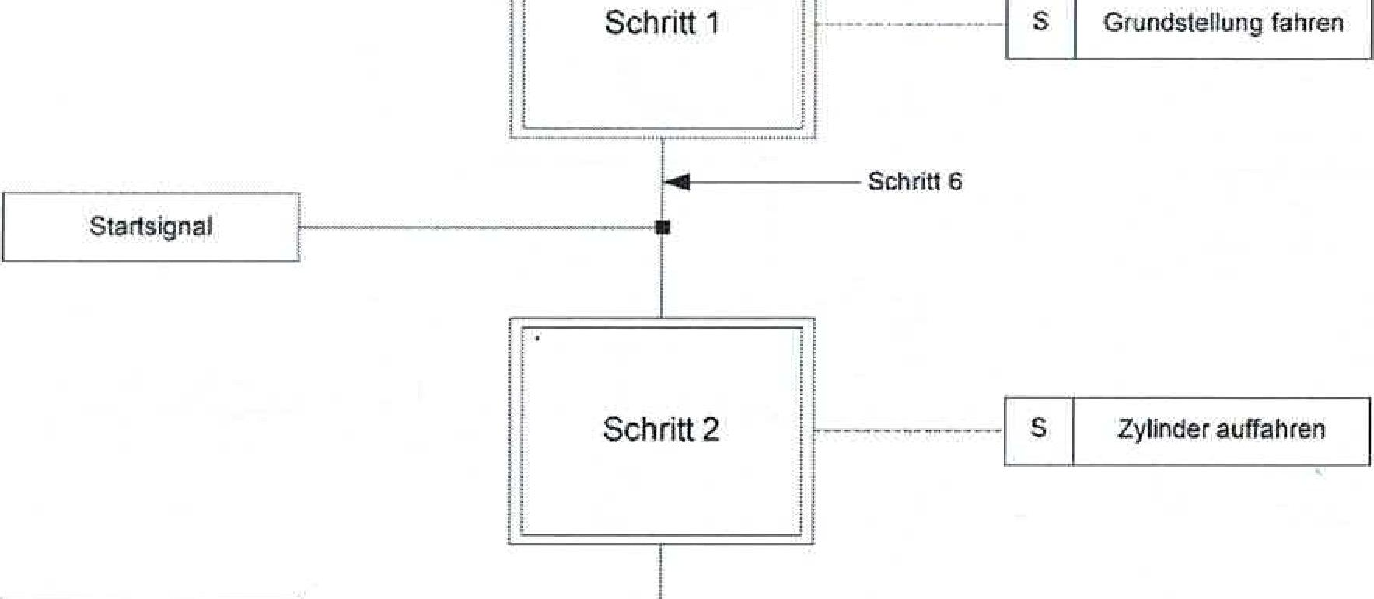

Font 6

Step 2

Step 1

S

Move to home position

S

Open cylinder

Start signal

Cylinder is opened

Ci by Dr-lng. Paul Christiani GmbH & Co. KG 51

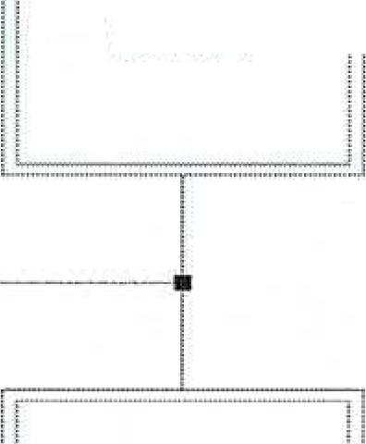Step 2

Step 3

|  |  |  |
| --- | --- | --- |
| Reference position reached |  | |
|  |  |
|  |  |  |
|  |  |  |

Step 4

Setting number value finished

i

i

Step 5

Ef

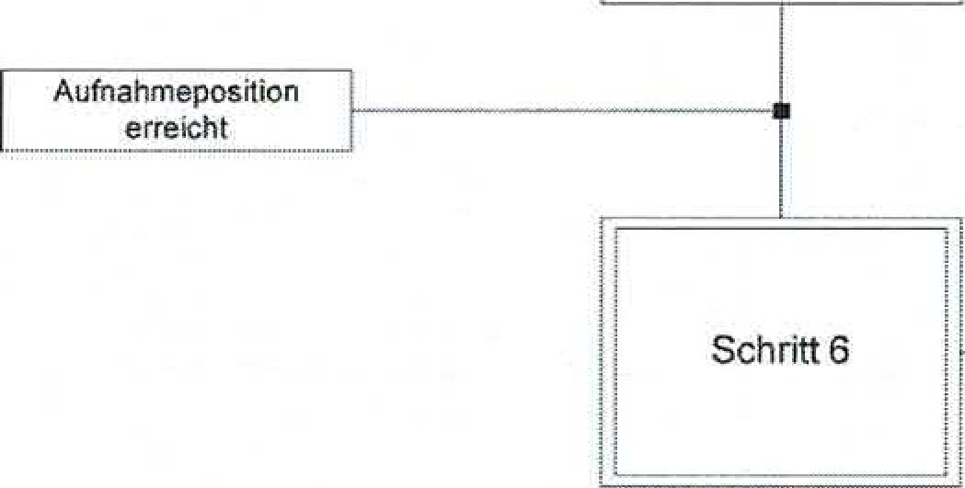

Recording*hrn*position reached

Step 6

[s Turn left until

Reference position

sf Set encoder reference count value

Turn left to recording position_i

S Chain end

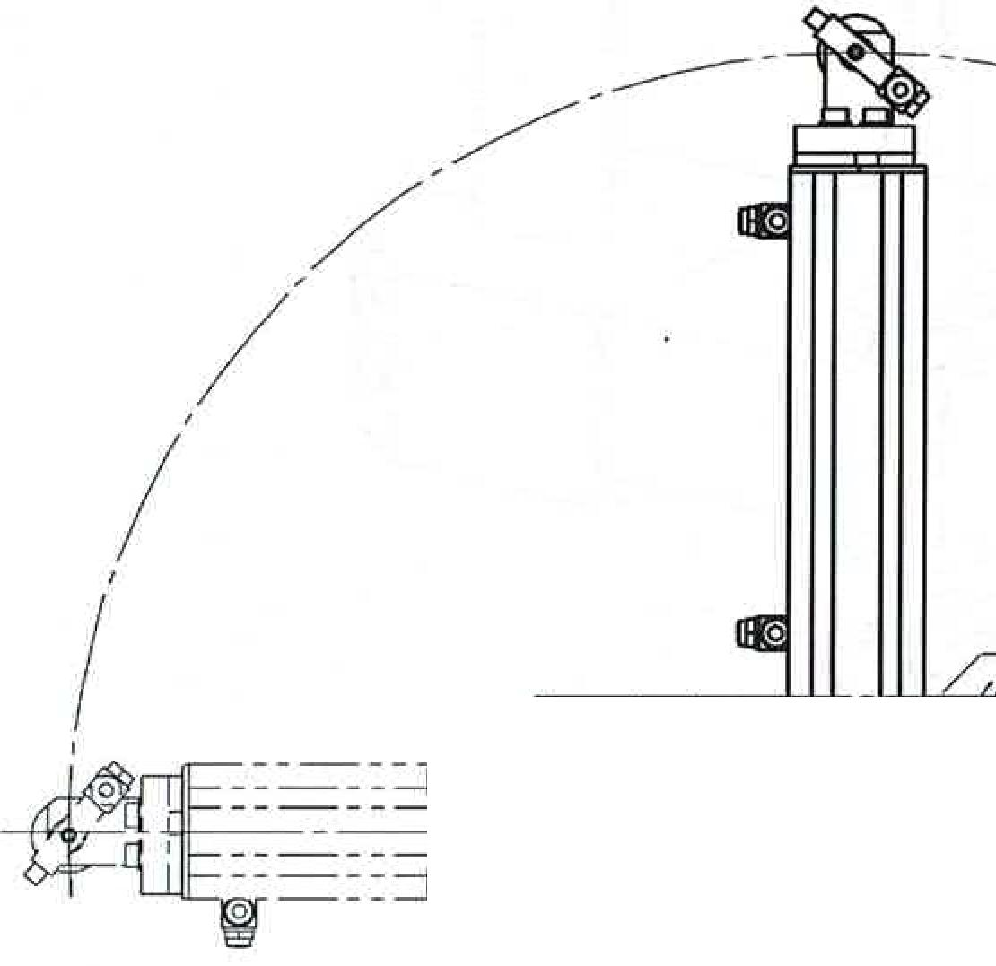**4 PLC program**

Handling device Technical documentation

**4.1 Program description**

The handling device functional assembly transports a workpiece from a pick-up position to a deposit position. These points are adjacent to one another.­the opposite relative to the center of the axis of rotation.

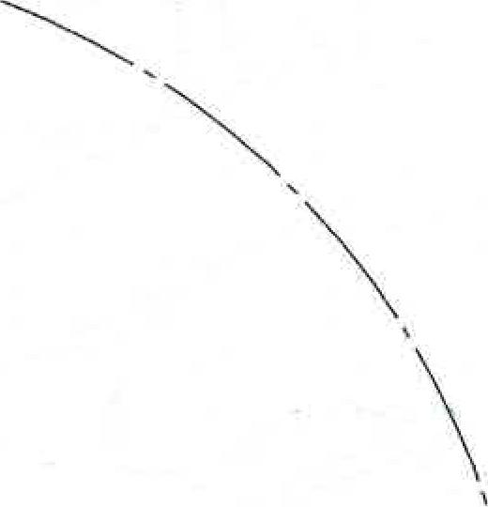

.--

Ima .31 rimpEll1IN THE'I.W■■■11■:=1=i

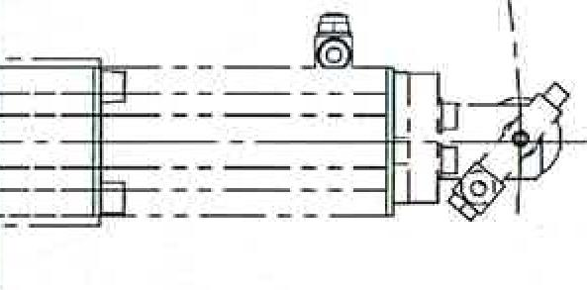

Storage position

-I M■11.,T•••MY1■11

I III l!UNE MI 'Z'W1

I **...1 ,**■■ ■■**, ,,,..„,**

**,1=".. 11,;.1=--,,,......67**

**ii** ;**Dggiatilikil**

**in thelia...I! IR .. ..... ....I**

Recording position

**17....ri,,...,_**

,iii.....,, ,,....

**sum 1.711111**

**1**

**........0.1aiA.,**

**n**

The program consists of two parts:

© by Dr.-Ing. Paul Christiani GmbH & Co. KG 39

**1. Travel to the home position, subprogram HHZA-GS**

The movement to the home position includes referencing the encoder. This occurs in the reference position. The reference position is the position in which proximity switch B1 is activated. This referencing is required after each power-off of the controller. After power is applied, the current position of the encoder is set to zero, regardless of the position of the arm. In order for the controller to know where the arm is actually located, the arm must have a reference position at­Before the reference run is released, the arm of the handling­device between the storage and reference positions. From the reference position, the arm then moves to the home position. The home­Position is defined here as the same arm position as in the recording­position only with retracted Z-axis.

The movement to the reference position and then to the home position is   
by turning the mode selector switch to the AUTO position, the so-called auto pulse. Automatic operation is started by

Pressing the start button while the mode selector is set to AUTOThis is only possible when the handling device is in its home position.

Technical documentation Handling device

40

©by Dr.-Ing. Paul Christiani GmbH & Co. KG

The reference position is shown in the following two images.

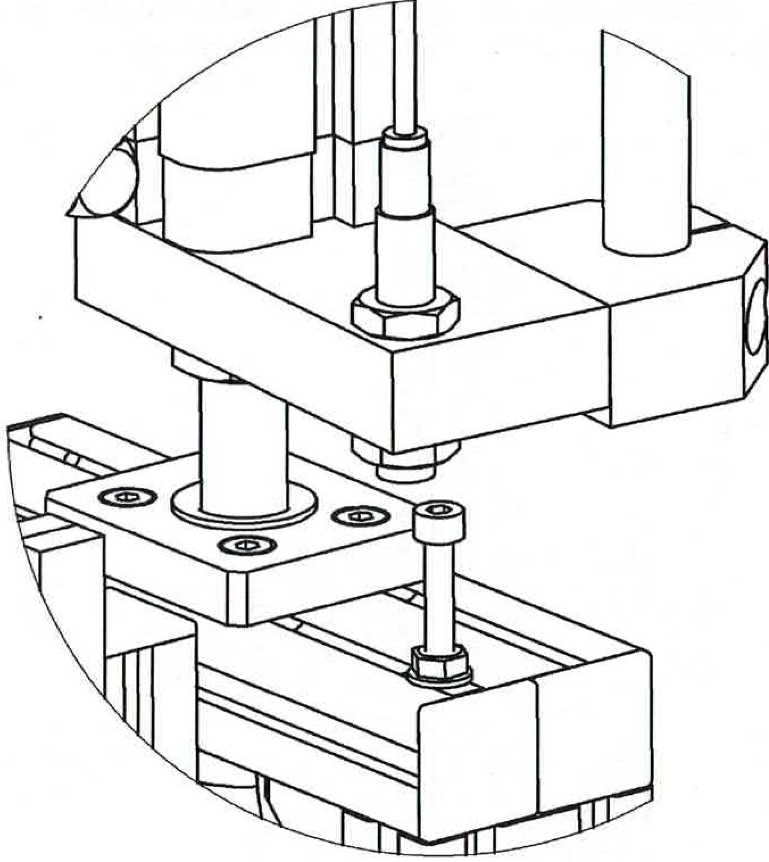

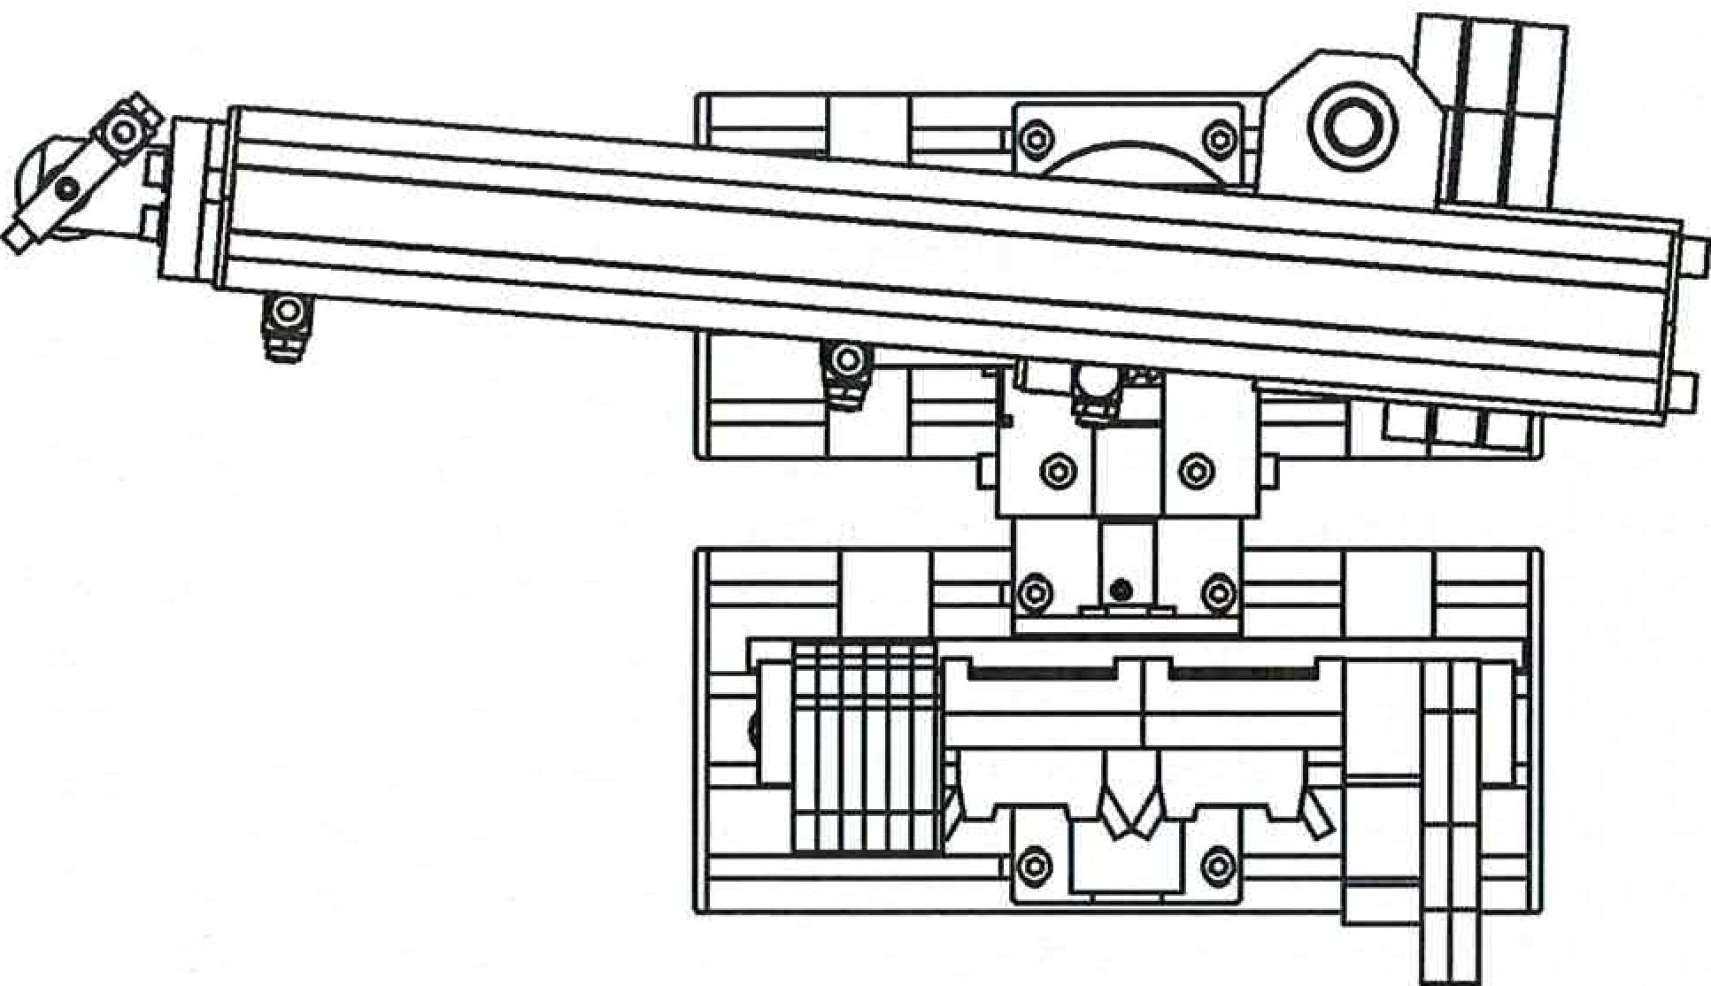

**2. Automatic mode, subroutineHHZA**

Handling device Technical documentation

© by Dr.-Ing. Paul Christiani GmbH & Co. KG

41

After the automatic operation was started by the start button,­The program responds to a signal that releases a workpiece in the pick-up position for pickup by the handling device. This signal must be a pulse.

This signal can be simulated by a switch or button on a control panel. Or it can be generated in the control system by another program, e.g., the program of an upstream conveyor belt (FB1).

For simplicity, the necessary assignments for the interfaces­signals are made in a higher-level program part.

**Times TI and T2**

These times are used in connection with the suction of the workpieces.

Ti is the time it takes to build up the negative pressure in the vacuum cleaner. T2 is the time it takes to release the negative pressure in the vacuum cleaner.

The times are used to ensure suction of the workpiece­place.

**Interface signals**

All interface signals are assignments that are only valid in the active step. Thus, the programmer does not have to worry about rack-setting the interface signals.

When using the handling device in a mechatronic system, the following recommendations must be observed due to the risk of collision:

1. Rotational movements always with retracted Z-axis and extendedY-Oh, see.
2. If high workpieces are to be transported, ensure that there is enough ground clearance­unity".

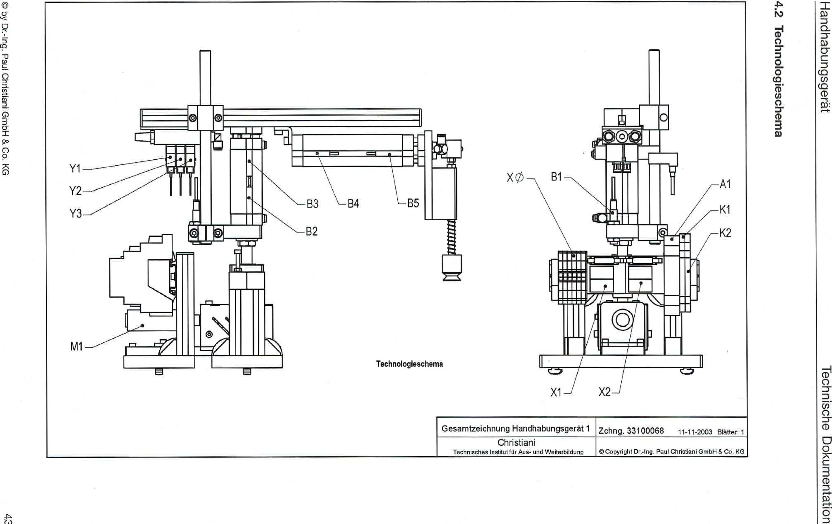

General drawing of handling device 1 drawing 33100068

11-11-2003 Blatter: 1

© by Dr-Ing. Paul Christiani GmbH & Co. KG

**emegose!6olompai**

1?Aabs6unqaipu1H

uo!leluewmpo agosp.pel

Technology scheme

Christiani

Technical Institute for Education and Training & Copyright DrAng. Paul Christiani GmbH & Co KG

**4.3 Configuration of the payer function**

Handling device Technical documentation

by Dr-lng. Paul Christiani GrnbH & Co. KG

45

The information in this chapter will enable you to provide the numerical values ​​of the rotary encoder to the PLC program.

The conversion of the encoder signals into a numerical value is performed by a system function of the CPU. In the user program, thezahi­worth working on.

The technological function “Numbers” of the Siemens CPU312C is used.The same technological function is available for all CPUs of the 31xC compact series.

For other controls an equivalent evaluation must be carried out­men will be.

The following tasks must be completed:

1. Wiring of the encoder signals
2. Parameterization of the hardware in STEP?
3. Parameterization of the system function block SFB COUNT SF647

**4.3.1 Wiring of the encoder signals**

The CPU 312C offers two channels for evaluating encoder signals. The first channel, channel 0, should be used here.

The following table shows only the connections relevant to the encoder. Of course, the power supply for the CPU's inputs and outputs must also be wired according to the data sheet.

The latch input for channel 0 is a particularly fast input that can be used to freeze the numerical value. However, due to the relatively low speed of the handling device, this special evaluation is omitted in the PLC program. In the program, the input for sensor 61 is monitored directly as a normal input, without a latch function.

The inputs for using the encoder signal are fixed as follows­laid.

CPU 3120, connector X1

|  |  |  |  |
| --- | --- | --- | --- |
| Connection | Na e/address | Pay | Signals from the FKB |
| 2 | DI+0.0 | Channel 0: A/Impulse | Encoder Channel A |
| 3 | DI+0.1 | Channel 0: B/Direction | Encoder Channel B |
| 4 | DI+0.6 | Channel 0: Latch | Reference position B1 |

 [Translated from German to English - www.onlinedoctranslator.com](https://www.onlinedoctranslator.com/en/?utm_source=onlinedoctranslator&utm_medium=docx&utm_campaign=attribution)

**Christiani**

**111111111111101111**

**Technical Institute for Training and Further Education**

**mMS training concept**

**Mechatronics/Automation Technology**

**Technical documentation**

**Functional module**

**Handling with Z-axis and rotary encoder**

**Order No. 644161st edition 1/04**

**© by Dr.-Ing. Paul Christiani GmbH & Co. KG**

0 by Dr.-Ing_ Paul Christiani GmbH & Co. KG 3

|  |  |  |
| --- | --- | --- |
| Handling device | | Technical documentation |
| **Table of contents**  **1 mechanics** | |  |
| 1.1 | Functional description | 5 |
| 1.2 | Overall drawing | 7 |
| 1.3 | Complete parts list | 13 |
| **2** | **E-pneumatics** |  |
| 2.1 | Pneumatic plan | 19 |
| **3** | **Electrics** |  |
| 3.1 | Data sheets | 21 |
| 3.2 | Circuit diagram / terminal plan | 27 |
| **4** | **PLC-program** |  |
| 4.1 | Program description | 39 |
| 4.2 | Technology scheme | 43 |
| 4.3 | Configuring the payment function | 45 |
| 4.4 | Function plan for home position travel | 51 |
| 4.5 | Function plan for automatic operation | 52 |
| 4.6 | Program steps home position travel | 55 |
| 4.7 | Program steps automatic mode | 57 |
| **5** | **Commissioning instructions** | 61 |

**1 Mechanics**

Handling device Technical documentation

© by Dr.-Ing. Paul Christiani GmbH & Co. KG 5

**1.1 Functional description**

The handling device can be used to perform so-called "pick-and-place" tasks. Workpieces are picked up from one location and placed at another.

This three-axis handling device covers a working range of 200°. Within this working range, any number of positions can be reached.

The X-axis is driven by a DC motor with integrated­tern rotary encoder, which is connected to the associated evaluation electronics and a PLC­can be controlled.

The left or right rotation of the drive is realized with a reversing protection circuit.

A non-rotating double-acting pneumatic cylinder with a stroke of 60 mm moves the "Y-axis" up and down.

The "Z-axis" is operated with a non-rotating double-acting pneumatic­cylinder with a stroke of 100 mm.

To hold the workpieces, the handling device is equipped with a vacuum­Equipped with suction device.

The functional module is completely constructed on two mounting platforms and can be flexibly mounted individually or together with other functional modules on an aluminum profile plate.

The supply voltage of the functional module is 24 VDC and is established via the 10-pin connecting cable. The air supply is via a 4 mm air connection (plug-in coupling); the operating pressure is 4 bar.

A DC motor with gearbox and rotary encoder, a reversing protection circuit, an inductive proximity switch, several reed switches, solenoid valves and a venturi nozzle are available for operation.

The connection to a controller is made via two 8-bit transfer connectors­For complete control of the functional module, seven digital­There must be five digital inputs and five digital outputs on the PLC.

Two of these inputs must be fast counter inputs to enable the encoder­to be able to evaluate the signal.

**Danger!**

Never move the arm of the handling device by hand when­clamped motor. This can destroy the motor or encoder­electronics drove.

The handling device has the following tasks in conjunction with further­mechatronic functional modules:

Technical documentation Handling device

6 ©by Dr.-Ing. Paul Christiani GmbH & Co. KG

To pick up work stacks from a conveyor belt and to a press for­processing.

To pick up workpieces from a conveyor belt and place them in a pin station via a turning station in order to finish the work after the pinning process.­piece to a press for further processing.

Collecting work pieces from a conveyor belt and transferring them to a high rack for storage.

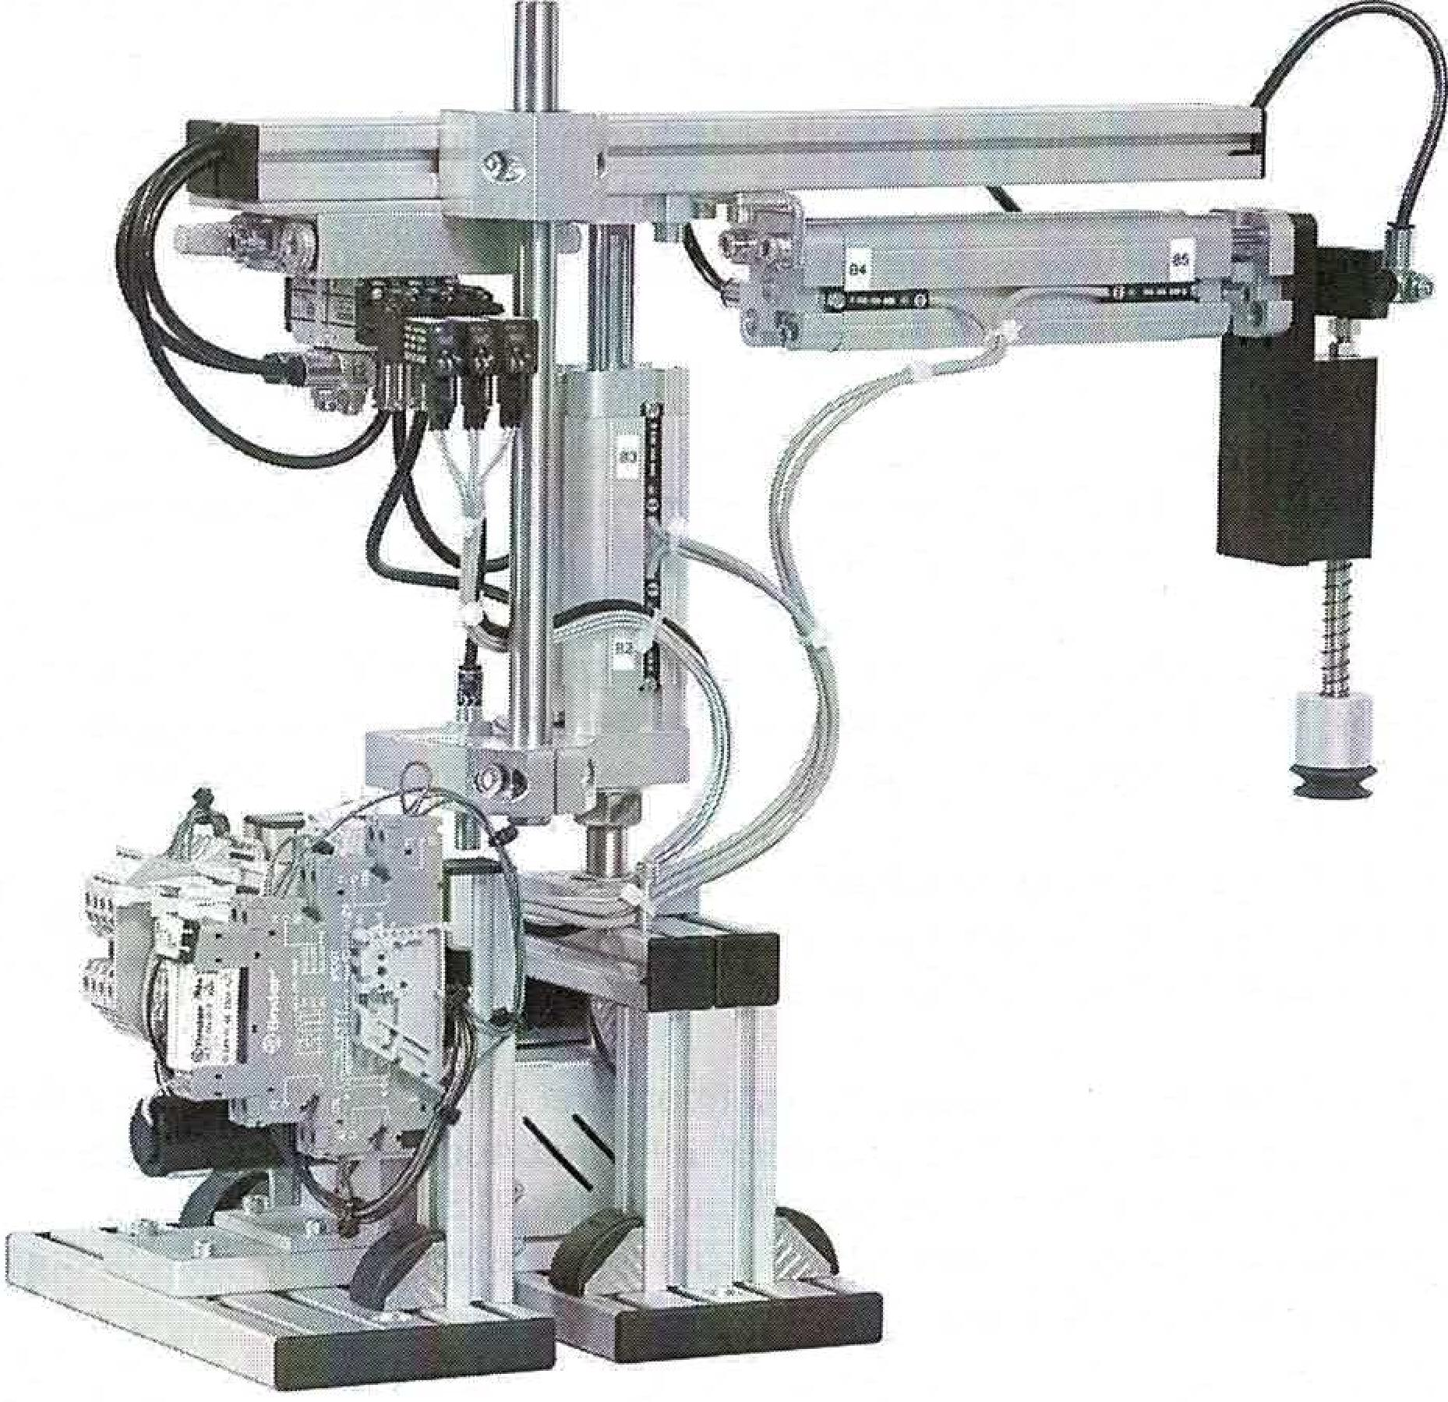

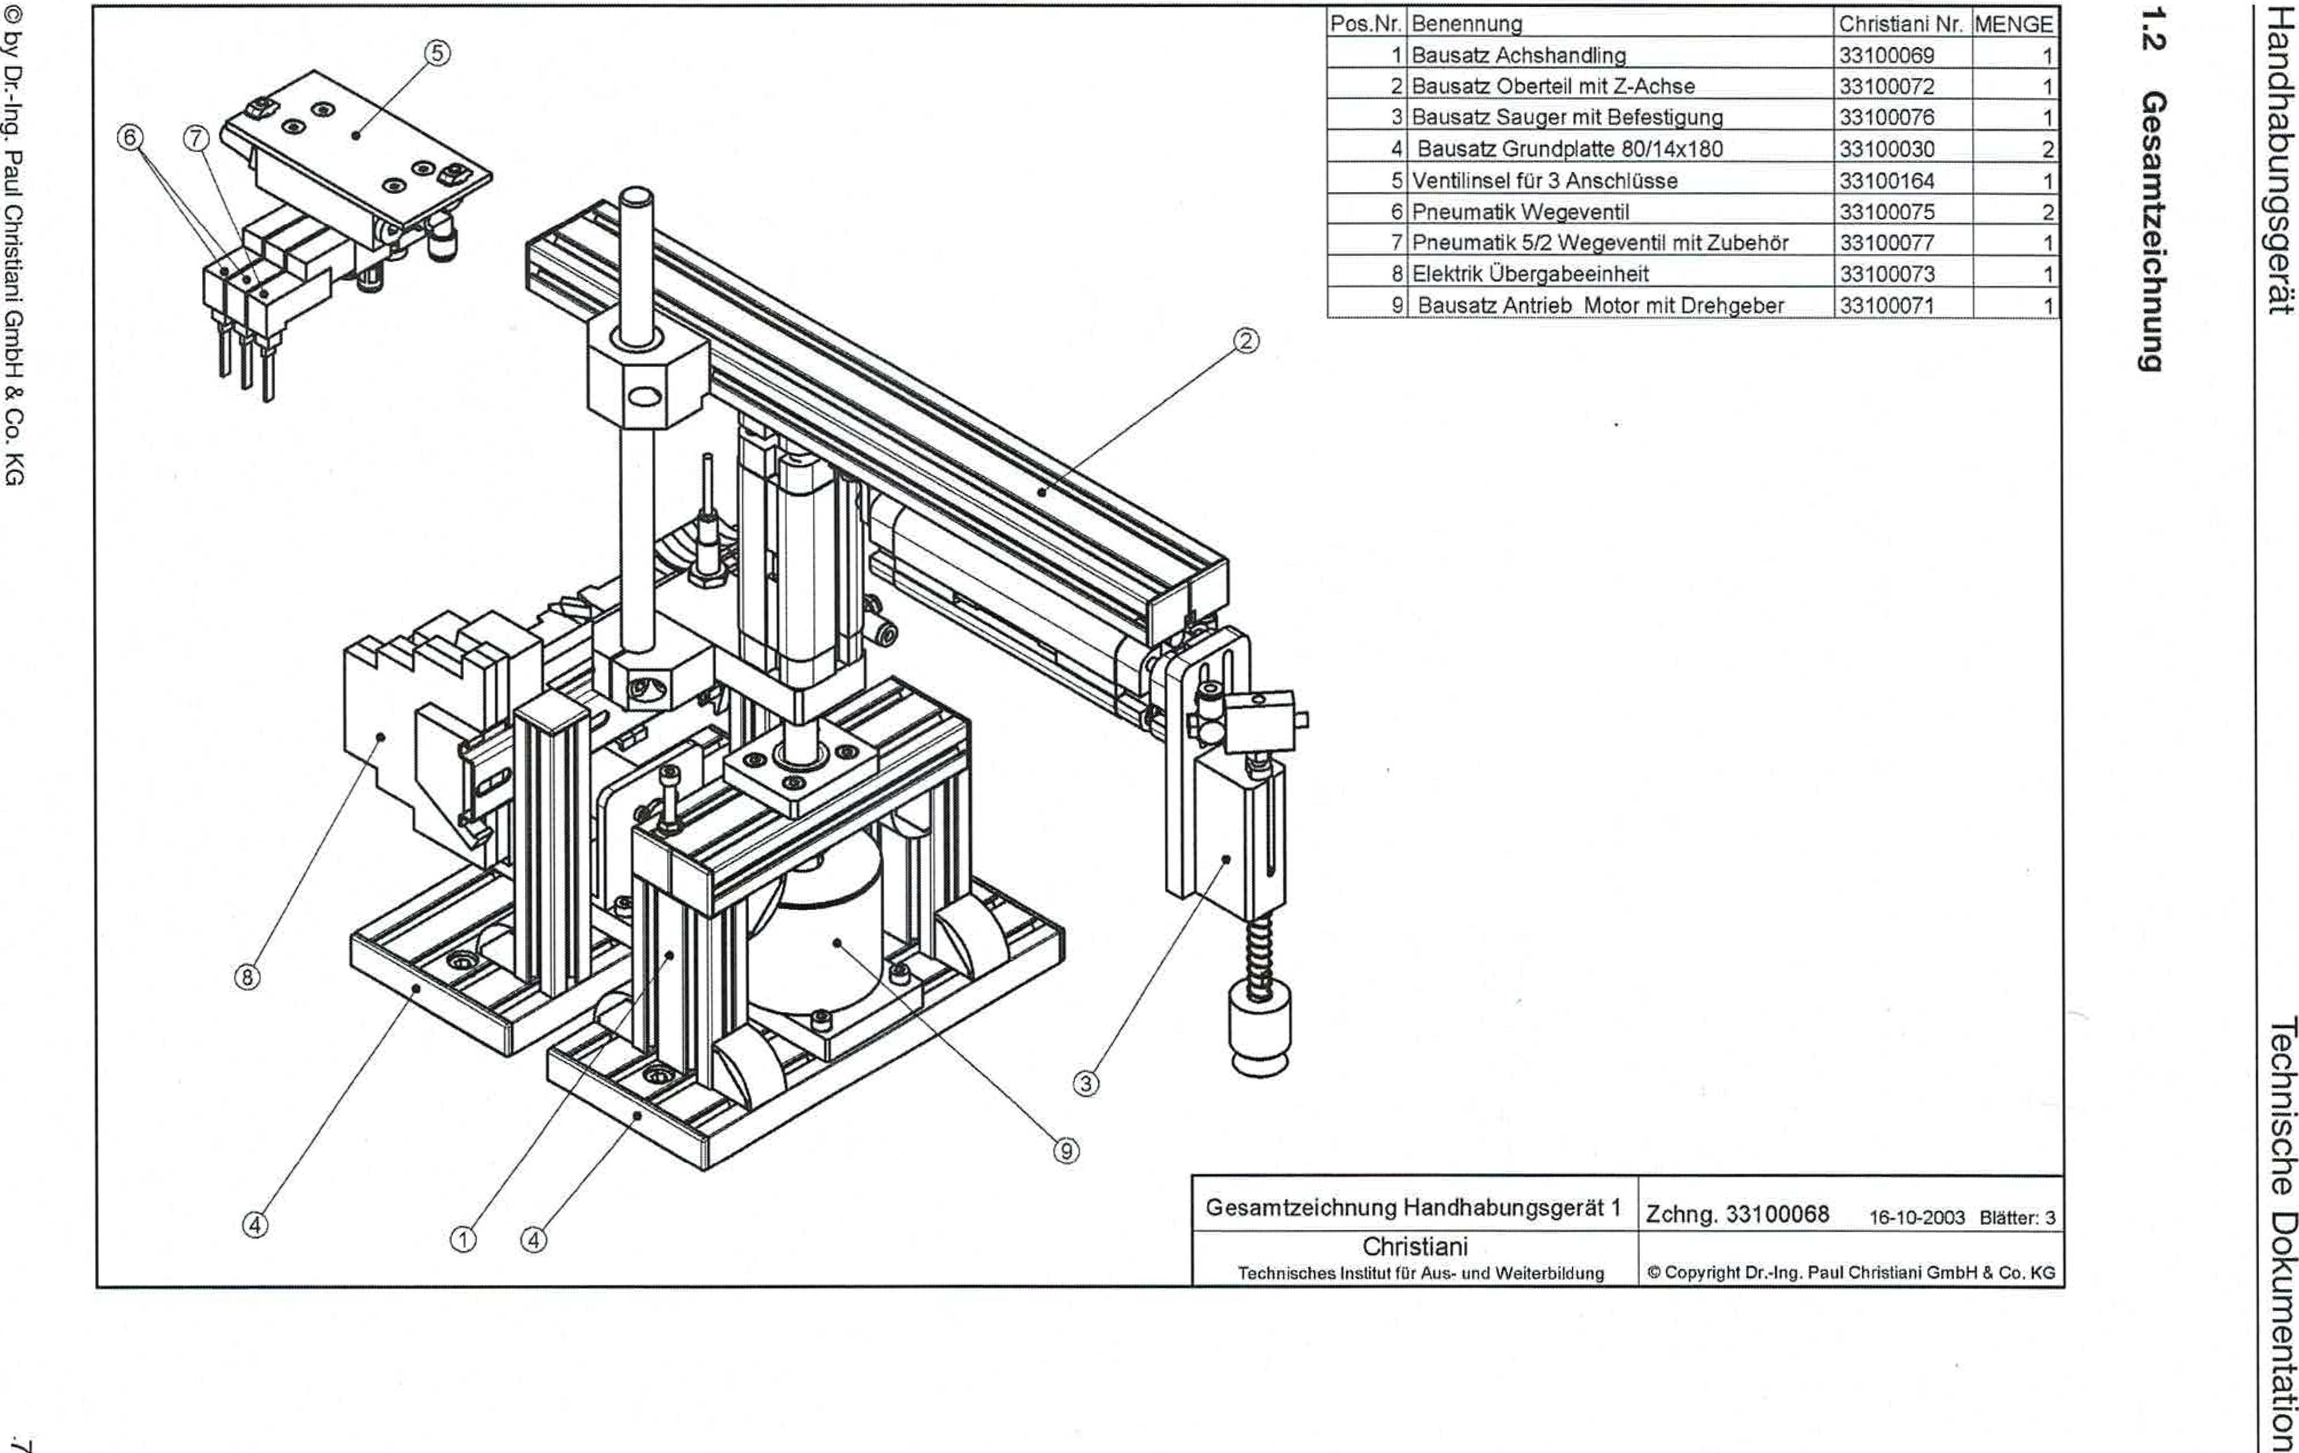

0 by ❑rt-Ing. Paui Christiani GmbH & Co. KG

**6unuqopzlwesap**

IV

ipiebsbunqeqpueH

uopluawnioci egospqool

|  |  |  |  |
| --- | --- | --- | --- |
| Item No. | designation | Christian' No. | CROWD |
| 1 | Axle Handling Kit | 33100069 | 1 |
| 2 | Kit upper part with Z-axis | 33100072 | 1 |
| 3 | Suction cup kit with attachment | 33100076 | 1 |
| 4 | Kit base plate 80/14x180 Valve island kr 3 connections | 33100030  33100164 | 2  1 |
| 5 |
| 6 | Pneumatic directional valve | 33100075 | 2 |
| 7 | Pneumatic 512 directional control valve with accessories | 33100077 | 1 |
| 8 | Electrical transfer unit | 33100073 | 1 |
| 9 | Kit drive motorwith rotary encoder | 33100071 |  |

General drawing of handling device 1

Drawing 33100068 16-10-2003 Pages: 3

Christiani

Technical Institute turOUT OF-end Continue birding

ra) Copyright Or;Ing. Paul Christiani GmbH & Co. KG

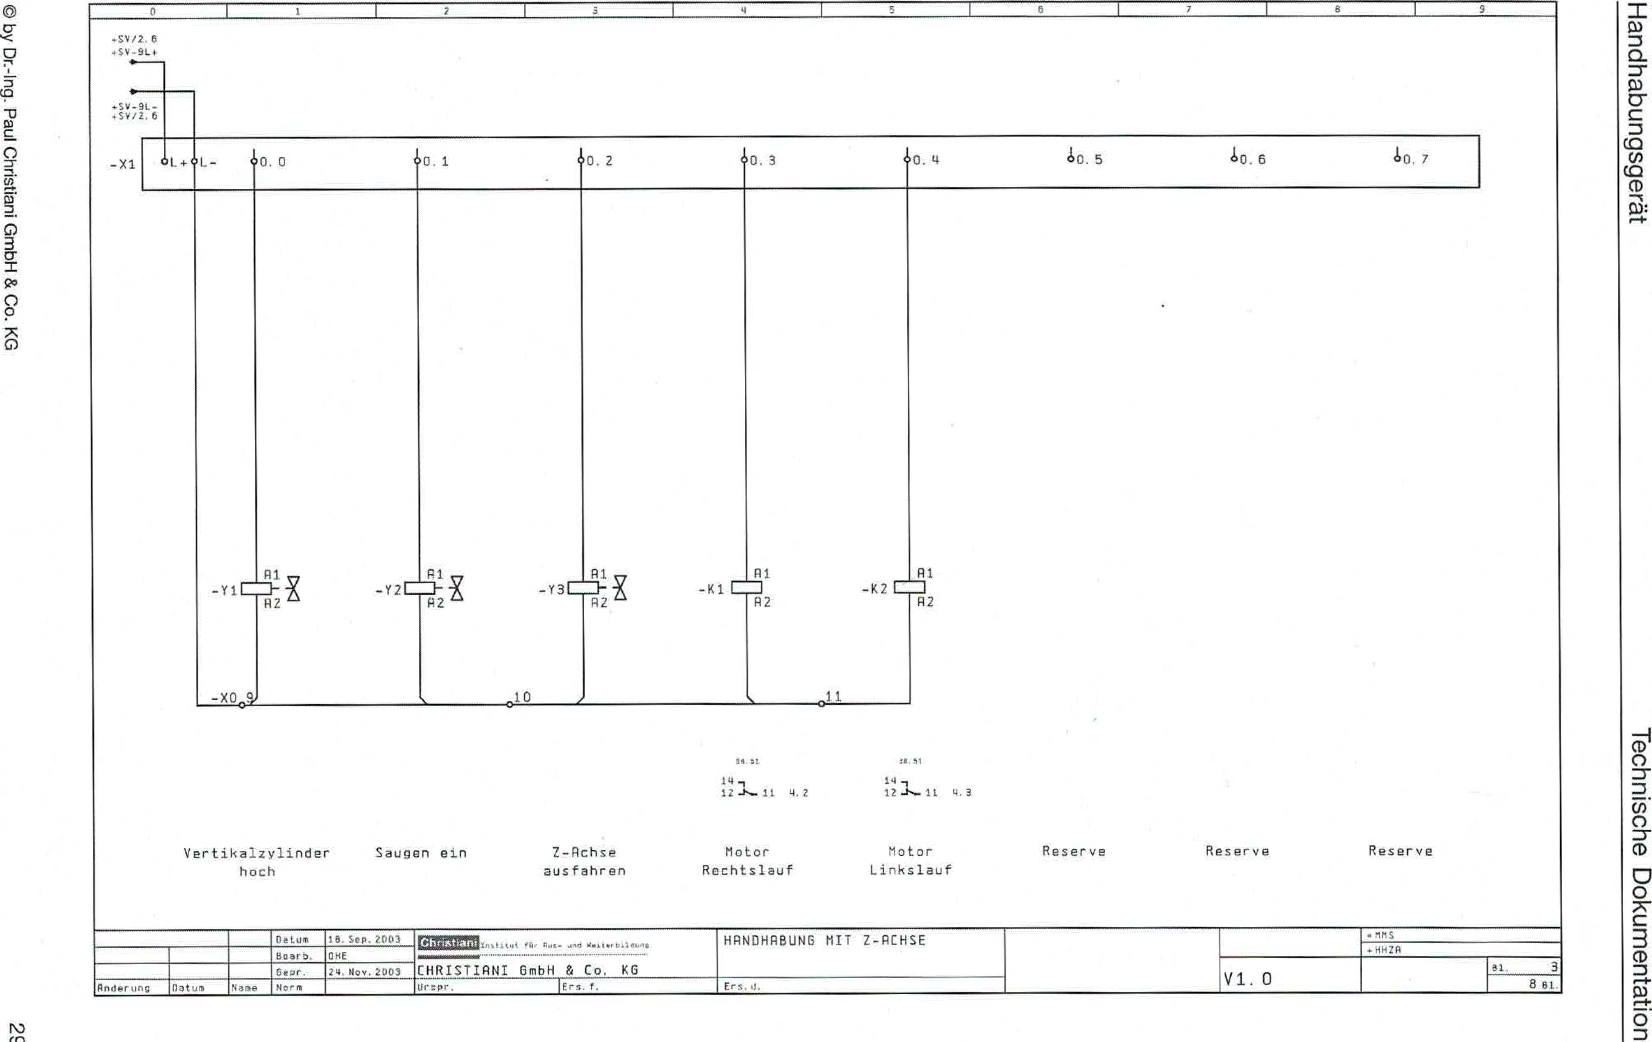

Rt1S

• /226

3

111. 0

881

©by Dr.-Ing. Paul Christiani GmbH & Co. KG

TpaabsbuncietipueH

uopluawmioa agospqoai

2

1

-Y2

Rig, H28

-K1

-Y3

12 —I,— 11 4.2

1212 V.3

Vertical cylinder Suction in 7-Rchse Motor Motor

high extend Clockwise rotation Left-hand rotation

reserve

reserve reserve

,S4/ fl

.52 -91_4-

|  |  |  |  |  |  |  |  |  |
| --- | --- | --- | --- | --- | --- | --- | --- | --- |
| 11..+01.- | t0.0 | 0.1 | 0.2 | 0.3 | 0.4 | 10.5 | 10. I | 10, 7 |

—X1

R1

R2

■ 011

010

-Y1

Al

R2

-K2

He, f. Frs. 0.

Change

flat urn

standard

name

September 2003

ORE

24.November 2053

Mg=St it **Yu I Y. I-,**

**MMIMINIMONW**

CHRISTIRMI GmbH & Co. KG

HANDLING WITH Z-RHEUM

Pa Sup

Beare

Gtepr.

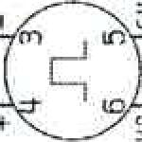

Orehgeber

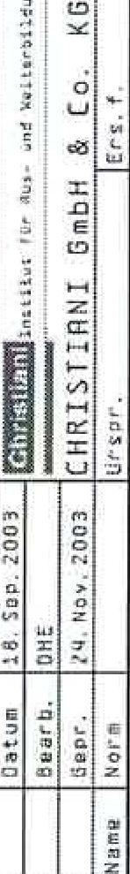

CIby Dr.-Ing. Paul Christian'GmbH & Co. KG 31

|  |  |
| --- | --- |
| Handling device | Technical documentation |

wiabsbunqeypueH

uopluewmio❑ alosiuyoei

© by Dr.-ing. Paul Christian' GmbH & Co. KG

|  |  |  |  |  |  |  |  |  |  |  |  |  |  |  |  |  |  |  |  |  |  |  |  |  |  |  |  |  |  |
| --- | --- | --- | --- | --- | --- | --- | --- | --- | --- | --- | --- | --- | --- | --- | --- | --- | --- | --- | --- | --- | --- | --- | --- | --- | --- | --- | --- | --- | --- |
| *0 I1 2 I I* 4 *I I* 5 *I I* 5 *1* 9 | | | | | | | | | | | | | | | | | | | | | | | | | | | | | |
| Klemmenplan Ess.33,, 07, 12.2001 | | | | | | | | | | | | | | | | | | | | | | | | | | | | | |
| Function text | | | | | |  |  |  |  | Cable name | Strip designation .MMS+HHZR-X0 | | | | | | | | | | | nweutecieN |  |  | |  |  | Page/ path | |
|  |  |  |  | dpi | Target name | | grp.psud | **-1041tunu**  -ueuueni | Bridges | | Gergte-  connection | | Target name | | anposuu |  |  |  | |  |  |
|  | | | | | |  |  |  |  |  | -B1 | | BN | 1 | | |  | | -X2 | | L+ |  |  |  | |  |  | /2.0 | |
| Vertical cylinder below | | | | | |  |  |  |  | -B3 | | BN | 1  2 | | |  | | -52 | | BN |  |  | |  |  | /2.2 | |
| Z-axle retracted | | | | | |  |  |  |  | -85 | | BN | 3  1 | | |  | | -84 | | BN |  |  | |  |  | /2.5 | |
| Z-axle extended | | | | | |  |  |  |  | -141 | | UE | 4 | | |  | |  | |  |  |  | |  |  | /2.5 | |
|  | | | | | |  |  |  |  | -131 | | BU | 51 | | |  | | -X2 | | L- |  |  | |  |  | /2.0 | |
| Vertical cylinder below | | | | | |  |  |  |  |  | -83 | | 8U |  | | |  | | -82 | | BU |  |  |  | |  |  | /2.2 | |
| Z-axle retracted | | | | | |  |  |  |  | -B5 | | BU | 1  7, | | |  | | -54  /2.5 | | BU |  |  | |  |  |  | |
| 2-axle extended | | | | | |  |  |  |  | -R1 | | M | 1  8 | | |  | |  | |  |  |  | |  |  | /2.6 | |
|  | | | | | |  |  |  |  | -YI | | R2 | 3 , | | |  | | -X1 | | L- |  |  | |  |  | /3.1 | |
| Suck a | | | | | |  |  |  |  | -Y3 | | A2 | 1  101 | | |  | | -Y2 | | R2 |  |  | |  |  | /3.2 | |
| Motor Clockwise rotation | | | | | |  |  |  |  |  | -K2 | | A2 | 11 | | |  | | -K1 | | R2 |  |  |  | |  |  | /3.4 | |
| ........ _ | | | | | |  |  |  |  |  | |  |  | | |  | |  | |  |  |  | |  |  |  | |
|  | | | | | |  |  |  |  | |  |  | |  |  | |  | |  |  |  | |  |  |  | |
|  | | | | | |  |  |  |  |  | |  |  | |  |  | |  | |  |  |  | |  |  |  | |
|  | | | | | |  |  |  |  |  | |  |  | |  |  | |  | |  |  |  | |  |  |  | |
|  | | | | | |  |  |  |  |  |  | |  |  | |  |  | |  | |  |  |  |  | |  |  |  | |
|  | | | | | |  |  |  |  |  | |  |  | |  |  | |  | |  |  |  | |  |  |  | |
|  | | | | | |  |  |  |  |  | |  |  | |  |  | |  | |  |  |  | |  |  |  | |
|  | | | | | |  |  |  |  |  | |  |  | |  |  | |  | |  |  |  | |  |  |  | |
|  | | | | | |  |  |  |  |  | |  |  | |  |  | |  | |  |  |  | |  |  |  | |
|  | | | | | |  |  |  |  |  |  | |  |  | |  |  | |  | |  |  |  |  | |  |  |  | |
|  | | | | | |  |  |  |  |  | |  |  | |  |  | |  | |  |  |  | |  |  |  | |
|  | | | | | |  |  |  |  |  | |  |  | |  |  | |  | |  |  |  | |  |  |  | |
|  | | | | | |  |  |  |  |  | |  |  | |  |  | |  | |  |  |  | |  |  |  | |
|  | | | | | |  |  |  |  |  | |  |  | |  |  | |  | |  |  |  | |  |  |  | |
|  | | | | | |  |  |  |  |  |  | |  |  | |  |  | |  | | .........  ....... |  |  |  | |  |  |  | |
|  | | | | | |  |  |  |  |  | |  | |  |  | |  |  |  | |
|  | | | | | |  |  |  |  |  | |  |  | |  |  | |  | |  |  |  | |  |  |  | |
|  | | | | | |  |  |  |  |  | |  |  | |  |  | |  | |  |  |  | |  |  |  | |
|  | | | | | |  |  |  |  |  | |  |  | |  |  | |  | |  |  |  | |  |  |  | |
|  | | | | | |  |  |  |  |  |  | |  |  | |  |  | |  | |  |  |  |  | |  |  |  | |
|  | | | | | |  |  |  |  |  | |  |  | |  |  | |  | |  |  |  | |  |  |  | |
|  | | | | | | | | | | | | | | | | | | | | | | | | | | | | | |
|  | |  | Date | 24.**NOY. 20D3** | **laniellt"...,0,.. ..„. ,,,,. ..,..,**  CHAISTIRNI GmbH & Co. KG | | | | | | | STRIP/PLUG:=MHS+HH2R-X0 Internal Voltage distribution | | | | | |  | |  | | | | | .m.15... | | | | |
| .HH70 | | | | |
|  |  |  | Oaarb, | OHE |
|  | | | | |  | | | | electric. 5 |
|  |  |  | Even,. | November 24, 2005 |
| 8 tbsp |
| Anderuns | Date | mama | Na-m |  | Dr.1-.mf. lHe:. f, | | | | | | | He, .7. | | | | | |

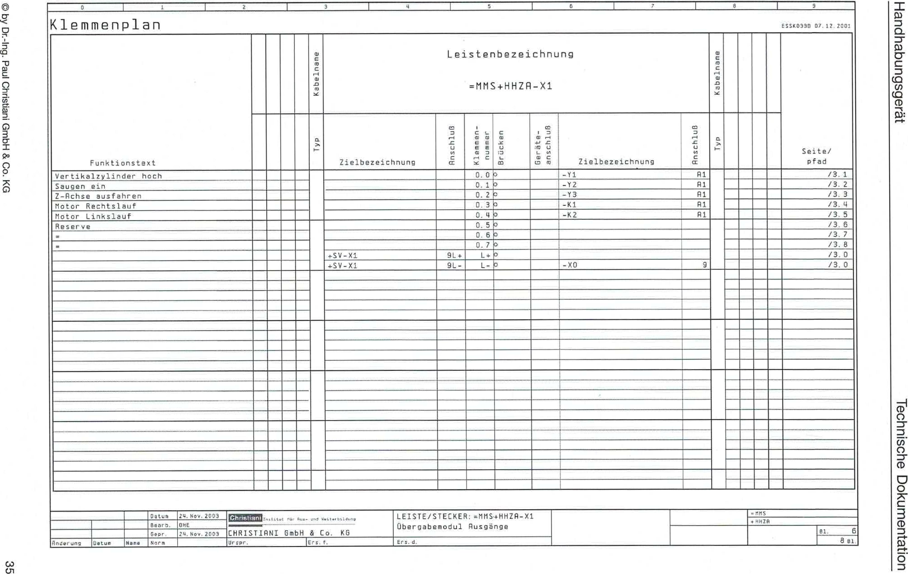

1

3

6

4

19580330 07. II 2007

Learning plan

by Dr.-Ing. Paul Christian' GmbH & Co. KG

C."

like 6s 6 tinge q pueH

uopluawnwa Nosimpei

|  |  |  |  |  |  |  |  |  |  |  |  |  |  |  |  |  |  |  |
| --- | --- | --- | --- | --- | --- | --- | --- | --- | --- | --- | --- | --- | --- | --- | --- | --- | --- | --- |
| Function text |  |  |  |  | aweuTacleA | Bar designation =MMS.OHZR-X1 | | | | | | | eweuTarlex |  |  |  |  | Page/ path |
|  |  |  |  |  | Target name | enTLI3suu | Jewvnu -uewweim | Bracken | [Tanned­connection | Target name | gnitosuu |  |  |  |  |  |
| Vertical cylinder high |  |  |  |  |  |  |  | 0.0 | 0 |  | -Y1 | Al |  |  |  |  |  | /3.1 |
| Suck gin |  |  |  |  |  |  | 0.10 |  |  | -12 | Al |  |  |  |  | /3.2 |
| Z-axle extend |  |  |  |  |  |  | 0.20 |  |  | -Y3 | Al |  |  |  |  | /3.3 |
| Motor Clockwise rotation |  |  |  |  |  |  | 0.30 |  |  | -Kl | Al |  |  |  |  | /3.4 |
| Motor Left-hand rotation |  |  |  |  |  |  | 0, Li | 0 |  | -K2 | Al |  |  |  |  | /3.5 |
| reserve |  |  |  |  |  |  |  | O. 5 | 0 |  |  |  |  |  |  |  |  | /3.6 |
| = |  |  |  |  |  |  | 0.6 |  |  |  |  |  |  |  |  | /3.7 |
|  |  |  |  |  |  |  | O.7 | 0 |  |  |  |  |  |  |  | /3.8 |
|  |  |  |  |  | +SV-X1 | 9L+ | L+ | 0 |  |  |  |  |  |  |  | /3.0 |
|  |  |  |  |  | +SY-XI | 9L- | L- | 0 |  | -XO | 9 |  |  |  |  | /3.0 |
|  |  |  |  |  |  |  |  |  |  |  |  |  |  |  |  |  |  |  |
|  |  |  |  |  |  |  |  |  |  |  |  |  |  |  |  |  |
|  |  |  |  |  |  |  |  |  |  |  |  |  |  |  |  |  |
|  |  |  |  |  |  |  |  |  |  |  |  |  |  |  |  |  |
|  |  |  |  |  |  |  |  |  |  |  |  |  |  |  |  |  |
|  |  |  |  |  |  |  |  |  |  |  |  |  |  |  |  |  |  |  |
|  |  |  |  |  |  |  |  |  |  |  |  |  |  |  |  |  |
|  |  |  |  |  |  |  |  |  |  |  |  |  |  |  |  |  |
|  |  |  |  |  |  |  |  |  |  |  |  |  |  |  |  |  |
|  |  |  |  |  |  |  |  |  |  |  |  |  |  |  |  |  |
|  |  |  |  |  |  |  |  |  |  |  |  |  |  |  |  |  |  |  |
|  |  |  |  |  |
|  |  |  |  |  |  |  |  |  |  |  |  |  |  |  |  |  |
|  |  |  |  |  |  |  |  |  |  |  |  |  |  |  |  |  |
|  |  |  |  |  |  |  |  |  |  |  |  |  |  |  |  |  |
|  |  |  |  |  |  |  |  |  |  |  |  |  |  |  |  |  |  |  |
|  |  |  |  |  |  |  |  |  |
|  |  |  |  |  |  |  |  |  |  |  |  |  |  |  |  |  |
|  |  |  |  |  |  |  |  |  |  |  |  |  |  |  |  |  |
|  |  |  |  |  |  |  |  |  |  |  |  |  |  |  |  |  |
|  |  |  |  |  |  |  |  |  |  |  |  |  |  |  |  |  |  |  |
|  |  |  |  |  |  |  |  |  |  |  |  |  |  |  |  |  |

|  |  |  |  |  |  |  |  |  |  |
| --- | --- | --- | --- | --- | --- | --- | --- | --- | --- |
|  | |  | Oats | *24.*November 2003 | gamsom—,„."tttt411 O1:IY | STRIP/PLUG:=MMS4HHZA-X1 |  |  | =r1rus |
|  |  |  | Boor, | 008 | + 407.8 |
| Transfer module Exits |  |
|  |  |  | thrush | November 24, 2003 | CHRISTIANI 6mbH & Co. KG |  | IL 6 |
|  |  |
| nnderuno | Date | Name. | standard |  | Ur. zpr. lErs. *t.* | He, d. |  |  | 8Ell |

1?..iabsbunqPypueH

uop.uweiump❑ aLioquqoal

0by Dr.-Ing. Paul Christiard GmbH & Co. KG

|  |  |  |  |  |  |  |  |  |  |  |  |  |  |  |  |  |  |  |  |  |  |  |  |  |  |  |  |  |
| --- | --- | --- | --- | --- | --- | --- | --- | --- | --- | --- | --- | --- | --- | --- | --- | --- | --- | --- | --- | --- | --- | --- | --- | --- | --- | --- | --- | --- |
| U 1 1 *I* [ 3I 4 1 5 r 1 1 B I *S* | | | | | | | | | | | | | | | | | | | | | | | | | | | | |
| Terminal diagram ESSX0330 07.12.2D01 | | | | | | | | | | | | | | | | | | | | | | | | | | | | |
| Function text | | | | | |  |  |  |  | atueuTageyi | Bar designation =MMS+HHZR -X2 | | | | | | | | | | ameuTagels |  |  | |  |  | Page/ path | |
|  |  |  |  | dAi | Target name | | unitosuH | _Lamanu -uaumaiA | uamoFil_g | 6erate-  connection5 | | Z2l designation | | anTgisub | (title]. |  |  | |  |  |
| Home Position | | | | | |  |  |  |  |  |  | |  | 0.00 |  |  | | —B1 | | BK |  |  |  | |  |  | /2.1 | |
| Vertical cylinder below | | | | | |  |  |  |  |
|  | |  | 0.10 |  |  | | -62 | | BK |
|  |  | |  |  | /2.2 | |
| Vertical cylinder °hen | | | | | |  |  |  |  |
|  | |  | 0.20 |  |  | | -63 | | 6K |
|  |  | |  |  | /2.3 | |
| Z-axis retracted | | | | | |  |  |  |  |
|  | |  | 0.3 | a |  | | -64 | | BK |
|  |  | |  |  | /2.4 | |
| Z-axis extended | | | | | |  |  |  |  |
|  | |  | 0.4 |  |  | | -65 | | BK |
|  |  | |  |  | /2.5 | |
| Changeability CH A | | | | | |  |  |  |  |  |  | |  | 0.5 | O |  | | -Al | | R1 |  |  |  | |  |  | /2.6 | |
| Converter unit CH 6 | | | | | |  |  |  |  |
|  | |  | 4,6 | 0 |  | | -Al | | P2 |
|  |  | |  |  | /2.7 | |
| reserve | | | | | |  |  |  |  |
|  | |  | 0.70 |  |  | |  | |  |
|  |  | |  |  | /2.8 | |
|  | | | | | |  |  |  |  |
| +SV-X1 | | 8L+ | 1+0 |  |  | | -X0 | | 1 |
|  |  | |  |  | /2.0 | |
|  | | | | | |  |  |  |  |
| +SV-X1 | | 8L- | L- | 0 |  | | -X0 | | 5 |
|  |  | |  |  | /2.0 | |
|  | | | | | |  |  |  |  |  |  | |  |  |  |  | |  | |  |  |  |  | |  |  |  | |
|  | | | | | |  |  |  |  |
|  | |  |  |  |  | |  | |  |
|  |  | |  |  |  | |
|  | | | | | |  |  |  |  |
|  | |  |  |  |  | |  | |  |
|  |  | |  |  |  | |
|  | | | | | |  |  |  |  |
|  | |  |  |  |  | |  | |  |
|  |  | |  |  |  | |
|  | | | | | |  |  |  |  |
|  | |  |  |  |  | |  | |  |
|  |  | |  |  |  | |
|  | | | | | |  |  |  |  |  |  | |  |  |  |  | |  | |  |  |  |  | |  |  |  | |
|  | | | | | |  |  |  |  |
|  | |  |  |  |  | |  | |  |
|  |  | |  |  |  | |
|  | | | | | |  |  |  |  |
|  | |  |  |  |  | |  | |  |
|  |  | |  |  |  | |
| ......  ________ ............ ............_ | | | | | |  |  |  |  |
|  | |  |  |  |  | |  | |  |
|  |  | |  |  | ... | |
|  | | | | | |
|  |  |  |  |
| ------- | |  |  |  | |
|  | | | | | |  |  |  |  |  |  | |  |  |  |  | |  | |  |  |  |  | |  |  |  | |
|  | | | | | |  |  |  |  |
|  | |  |  |  |  | |  | |  |
|  |  | |  |  |  | |
|  | | | | | |  |  |  |  |
|  | |  |  |  |  | |  | |  |
|  |  | |  |  |  | |
|  | | | | | |  |  |  |  |
|  | |  |  |  |  | |  | |  |
|  |  | |  |  |  | |
|  | | | | | |  |  |  |  |
|  | |  |  |  |  | |  | |  |
|  |  | |  |  |  | |
|  | | | | | |  |  |  |  |  |  | |  |  |  |  | |  | |  |  | ... |  | |  |  | .........._ ......._ | |
|  | | | | | |  |  |  |  |
|  | |  | |
|  | | | | | |  |  |  |  |
|  | |  |  |  |  | | | |  |
|  |  | |  |  |  | |
|  | | | | | |  |  |  |  |
|  | |  |  |  |  | | | |  |
|  |  | |  |  |  | |
|  | | | | | |  |  |  |  |
|  | |  |  |  |  | | | |  |
|  |  | |  |  |  | |
|  | | | | | |  |  |  |  |  |  | |  |  |  |  | | | |  |  |  |  | |  |  |  | |
|  | | | | | |  |  |  |  |
|  | |  |  |  |  | | | |  |
|  |  | |  |  |  | |
|  | | | | | | | | | | | | | | | | | | | | | | | | | | | | |
|  | |  | Date | Nov 24, 2D03 | CHRISTIAN ANI GmbH & Approx. KB | | | | | | | STRIP/PLUG:.HMS+HH2R-X2 Output module inputs | | | | |  | |  | | | | | .Lq..s | | | | |
|  |  |  | Bear!, | UM |
| 4e1-17R | | | | |
|  | | | | |  | | | | Bi. |
|  |  |  | Dap, | 24.Nov.2020 |
| Dudorung | Date | Hamm | Nor. |  | ul,or, k".I. | | | | | | | era.d. | | | | |
| 8 |

**FAULHABER**

Handling device

Technical documentation

**024 SR 036 SR**

rpm

A

mNm -mNm

rpmN mV/rpm rnN rn/AA/mNm

rpm/mNm pH

**ms**

. gcm' '103rad/s2

KIVV

1,c

7,800 0.005 16.9 0.22

7,800 0.007 19.0 0.2

219 4.560 43.50 0.023

3283.040 29.10 0.034

H111 !800 11 12.6174

462

; 1 800 11

[ 2.3 74

24 36.30 3.88 81

36 91.40 3.46 80

18 17.50 4.54:82

• 8 100 0.010 21.4 0.21

454 2,200 21.00

0.048







3

0.56 3.92 80

8 100 0.066 18.5 0.23

2,730 0.366 3.49 0.286

438

11

11

2.4 77

379,450

11

2.8

77

394

200

11

2.7

74

387 .45 11 2.7 78

6

1.94

4.55

82

8,200 7,800

0.029 0.014

21.2 19.8

0.2

0.2

1657

0.069

65209

12 8.71 4.05 82

1 380 0.725 6.92 0.144

|  |  |
| --- | --- |
| **D.C1(leirisimoto_ren**  Precious metal commutation  **Series 2224.R.SR** | 4.2 W_att____  **Can be combined with:**  Gearbox  20/1, 22E, 22/2, 22/5, 22/6, 23/1, 38/3 Pulse generator:  **1E2** |

1 Nominal voltage

2 Connection resistance

3 Output power

**4**Efficiency

5 Idle speed

6 No-load current (for Weller o 2.0 mm)

7 Stopping torque

8 Friction torque

9 Speed ​​constant

10 Generator voltage constant

11 Torque constant

12 Current constant

13 Slope of the nM characteristic curve

14 Connection inductance

15 Mechanical air time constant

16 Rotor moment of inertia

17 Angular acceleration

|  |
| --- |
| 18 thermal resistors  19 Thermal time constant  20 Operating temperature range:   * Motor   -Rotor, max. permissible |

**2224 U 003 SR 006 SR 012 SR 018 SR**

Ball bearing (special design) 2.0

8

0.8 10

Sintered bearing (standard) 2.0

1.5

0.2

20

0.03

0.015

0.2

0.2

Steel, black coated

46

clockwise viewed on output shaft

Ball bearing, preloaded (special design)

20 **mm**

8 N

0.8 N

10 N

0.015

0

mm corn

|  |
| --- |
| U.NR  p2max  max.  nG la  Mw  **MR** |

Type/AMTm

iX Mar.

**Rth1**/ Rth 2 5/20 twl/T, :6.8/440

- 30 ... + 85 (special version - 55 ... + 125)+125

|  |
| --- |
| 21 VVelle storage  22 Shaft load, max. permissible:   * for shaft diameter * radial at 3000 rpm (3 mm from bearing) * axial at 3000 rpm * axially at standstill   23 Wave play:   * radial * axial |

24 Housing material

25 weight

26 Direction of rotation

**Recommended values**

|  |  |  |  |  |  |  |  |  |  |  |  |  |
| --- | --- | --- | --- | --- | --- | --- | --- | --- | --- | --- | --- | --- |
| 27 speed his  28 Continuous torque up to  29 Thermally permissible continuous current |  | 8,0005  2,200 |  | 8,0005  1,200 |  | 8,0005  0.570 |  | 8,0005  ; 0.400 |  | 8,000 8,000  15  10,280 0.180 |  | rpm mNm : A |
|  |  |  |  |  |  |  |
|  |  |  |  |  |  |  |  |  |  |  |  |

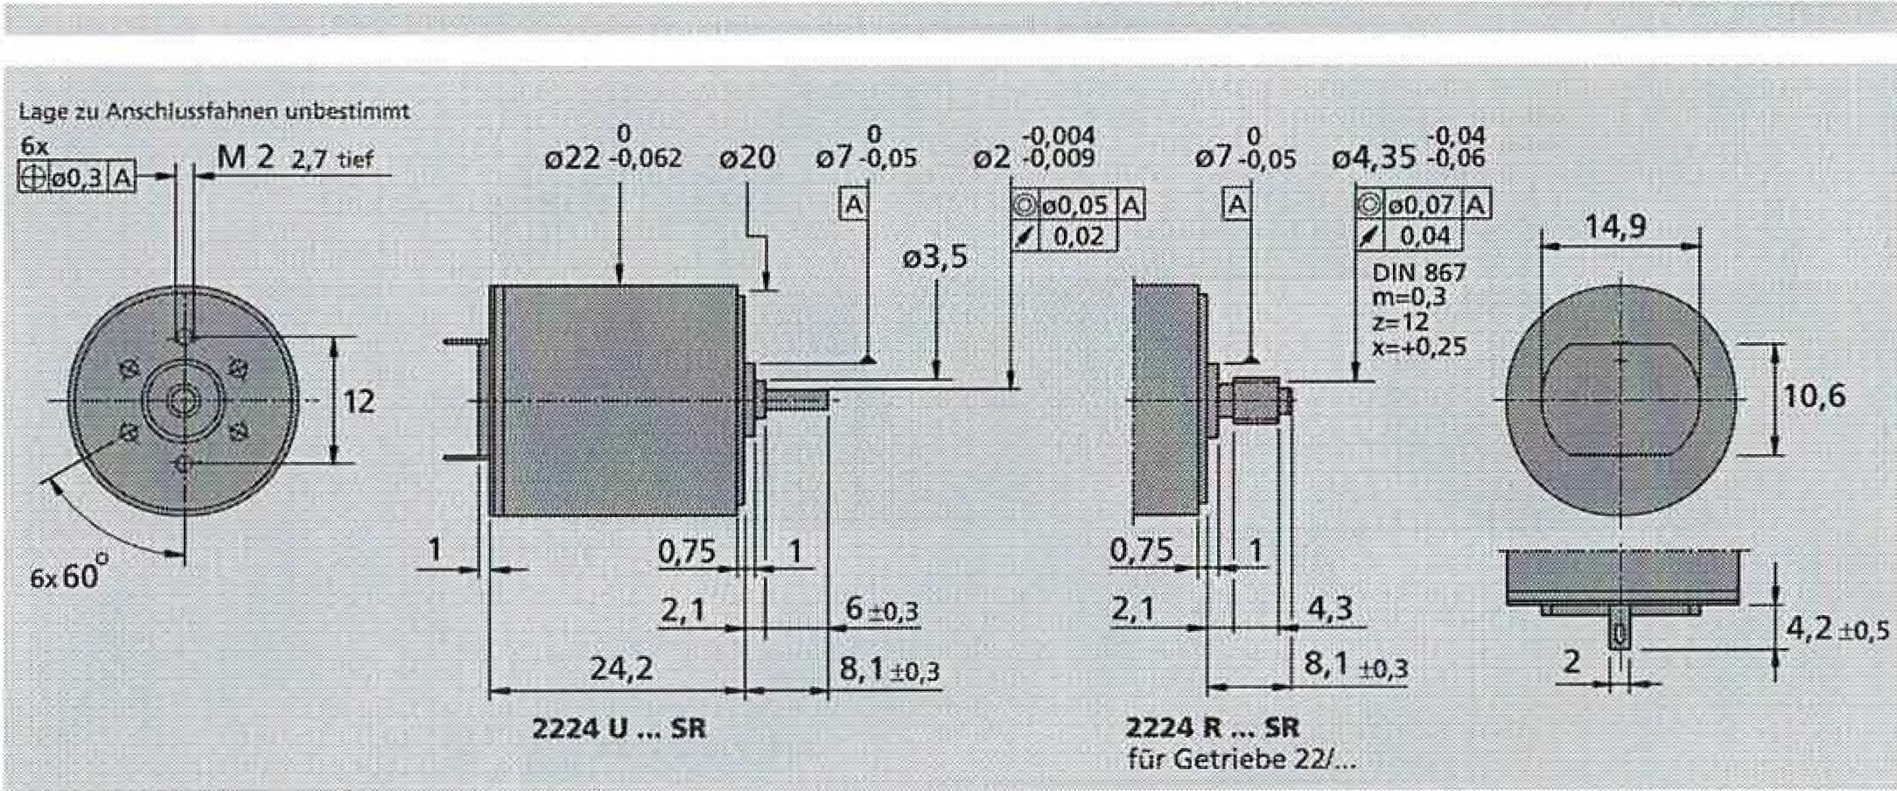

0.75

2.1

24.2

**2224 U .,. SR**

4.3

4.2 ± 0.5s

8.1+0.3

o0 07 A

/ 0.04

DIN 867 rn.0.3 z=12 xtr+0.25

**14.9**

**2224 R ."SR**

farGearbox 22/...

10.6

-0.004

-o,os

o22-0.062

02 -0.009

o20

Place connection flags undetermined

6x

**M**2*2.7*ran

0.05 o4.35 -1)A0846

|  |  |  |
| --- | --- | --- |
| For further technical details see "Technical Information". Special versions for DC micromotors are available on page 61. | Subject to change |  |
| © by Dr.-Ing. Paul Christiani GmbH & Co. KG |  | 23 |

**FAULHABER**

Technical documentation

Handling device

|  |  |  |  |
| --- | --- | --- | --- |
| **Pianet gear** |  | **0,B_Nm** |  |
|  |  |
| **Series 22E** | Can be combined with:  DC micromotors-  2224 ... SR, 2230, 2233  DC motor-tacho combinations:2251 | | |

|  |
| --- |
| 22E 22EC 22EK |

plastic plastic

Housing material

GearsAterkstoff

Max. recommended input speed for continuous operation

Gear play, unloaded output shaft bearing

Maximum permissible shaft load:

* radial (5 mm from the mounting flange)
* axial

Maximum pressing force

Layer game (yeasured on the layer):

- radial

* axial

Operating temperature range

plastic1plastic

15000 rpm <3,

ISintered bearings

3N 15 3 N 415 N

'40.03 mm5_0.25 mm - 30 ...+ 65'C

plastic plastic

5000 rpm' "'3-

ball bearings

|  |  |  |
| --- | --- | --- |
| :5 50N '5 5N5 15 N |  |  |
|  | 9r.g" |
|  |  |

5000 rpm ceramic bearings

5 15 N 5 2 N 15 15 N

**Technical data**

Reduction Order Quantity Weight Length

arrest Code for gearbox• without without

(nominal) i Engine" stages Engine Engine

L2 Ll

G mm mm

19:1 B 2 17 27.8 51.3

28:1 A 2 17 27.8 51.3

69:1 B 3 19 32.8 56.3

102 :1 A 3 19 32.8 55.3

152 :1 A 3 19 32.8 56.3

249:1 8 4 20 37.8 61.3

369 '1 A 4 20 37.8 51.3

545 :1 A 4 20 37.8 61.3

809 :1 A 4 20 37.8 61.3

896 :1 8 5 22 42.8 66.3

1,327:1 A 5 22 42.8 66.3

1,966:1 A 5 22 42.8 66.3

2,913:1 A 5 22 42.8 66.3

3,225:1 B 6 24 47.8 71.3

4,315:1 A 5 22 42.8 66.3

4,778:1 A 6 24 47.8 71.3

7,078:1 A 6 24 47.8 71.3

10,486:1 A 6 24 47.8 71.3

15,534:1 A 6 24 47.8 71.3

23 014 :1 A 6 24 47.8 71.3

2224 :

|  |  |  |  |  |  |  |
| --- | --- | --- | --- | --- | --- | --- |
| 5 0.03mm 15 0.25mm -20 +85'C | | | | 150.015 mm '50.25 mm  -30 .4-85°C | |  |
|  | |  | |  | |  |
| Long with  2230  Li mm | Motor  2233  Ll mm | torque  Duration- Short-term Direction of rotation  2251 operation operation the wave  Li M*max.* M max.  mm mNm mNm | | | | Effectiveness  degree |
| 57.1 | 59.7 | 78.7 200 | | 400 | | 78 |
| 57.1 | 59.7 | 78.7 200 | | 400 | | 77 |
| 62.1 | 64.7 | 83.7 300 | | 600 | | 69 |
| 62.1 | 64.7 | 83.7 | 300 | 500 | | 68 |
| 62.1 | 64.7 | 83.7 | 400 | 800 | | 67 |
| 57.1 | 69.7 | 88.7 | 400 | 800 | | 62 |
| 67.1 | 69.7 | 88.7 500 | | 1,000 |  | 61 |
| 67.1 | 69.7 | 88.7 600 | | 1,000 |  | 60 |
| 67.1 | 69.7 | 88.7 600 | | 1,000 |  | 59 |
| 72.1 | *74.7* | 93.7 600 | | 1,000 |  | 55 |
| 72.1 | 74.7 | 93.7 600 | | 1,000 |  | 54 |
| 72.1 | 74.7 | 93.7 | 500 | 1,000 |  | 53 |
| 72.1 | 74.7 : | 93.7 | 600 | 1,000 |  | 52 |
| 77.1 | 79.7 I | 98.7 | 600 | 1,000 |  | 49 |
| 72.1 | 74.7 , | 93.7 | 600 | 1,000 |  | 51 |
| 77.1 | 79.7 : | 98.7 | 600 | 1,000 |  | 48 |
| 77.1 79.7 1 | | 98.7 | 600 | 1,000 |  | 47 |
| 77.1 79.7 ! | | 98.7 | 600 | 1,000 |  | 46 |
| 77.1 79.7 : | | 98.7 | 600 | 1,000 |  | 46 |
| 77.1 79.7 | | 98.7 | 600 i | 1,000 |  | 46 |

z.8. Order description:

2224 B 012 SR 22E 19:1

These gearboxes are only available assembled with motors,

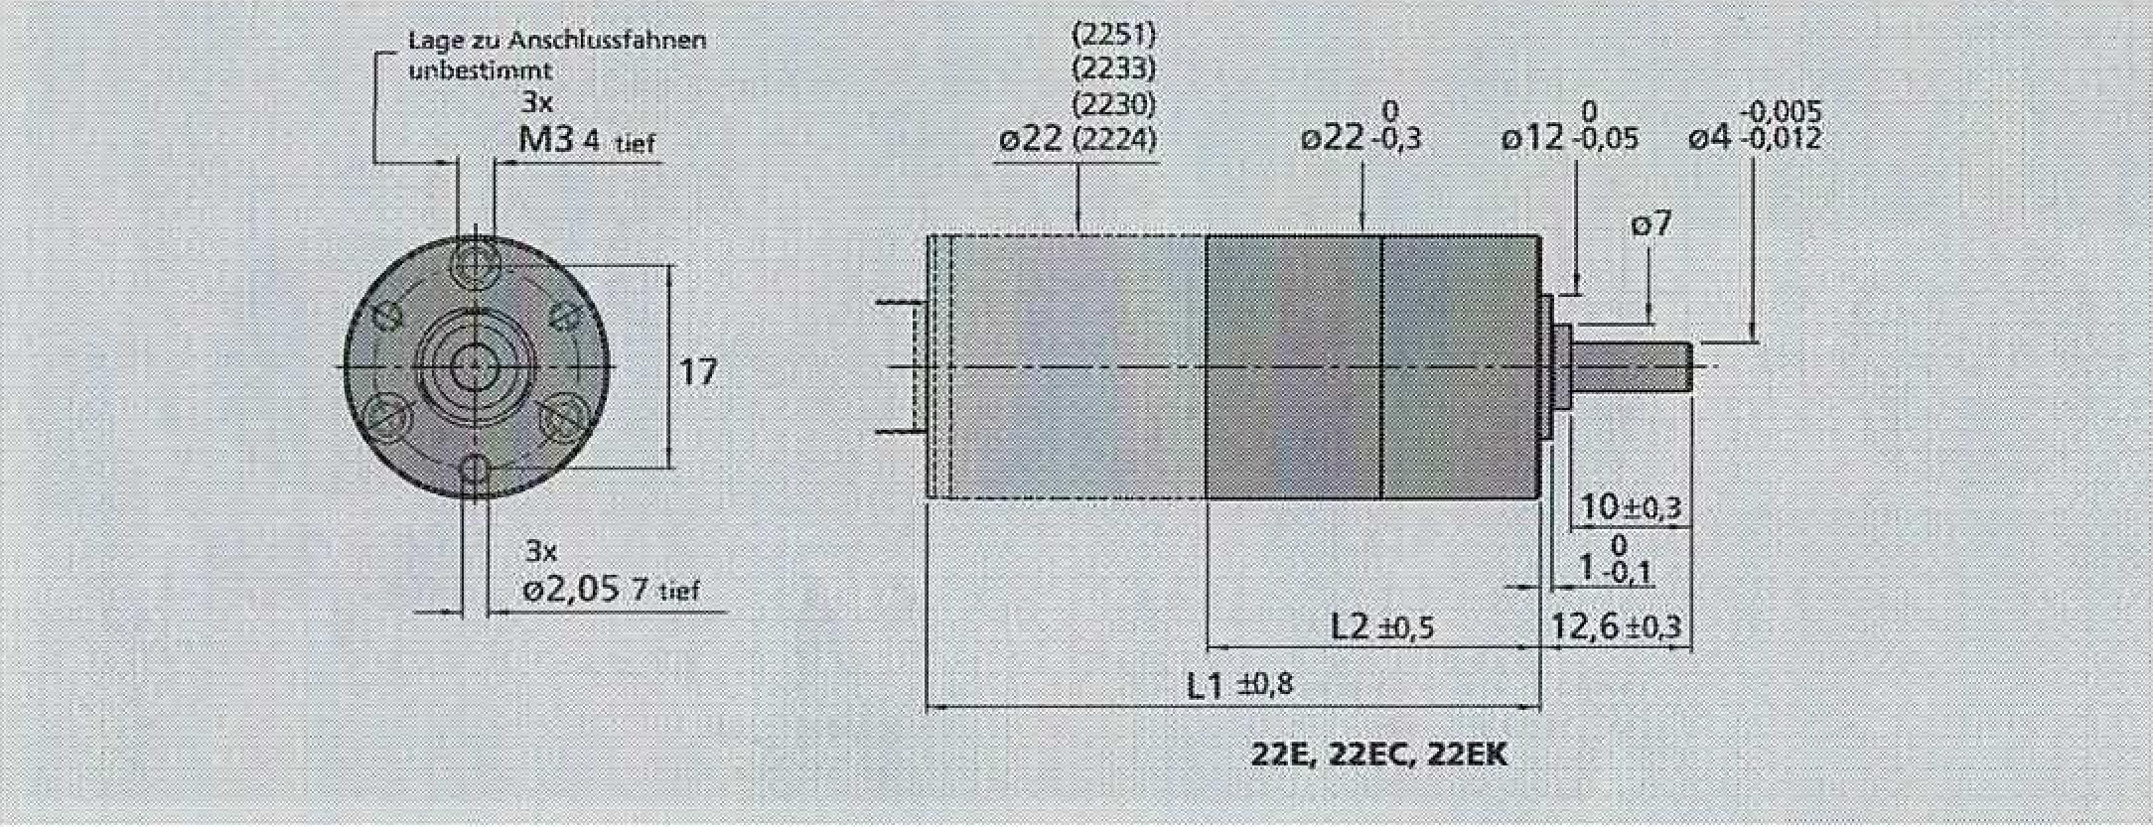

**22E, 22EC, 22EK**

o22

Location of...Anschitissflags

ror,determineOlxt

**143**4tef

**17**

0 0 41-0.005

o12 -9.0s 04 .012

(2251) (2233) (2230)  
022(2224)

0.8

24 Qby Dr.-Ing. Paul Christiani GmbH & Co. KG

|  |  |  |
| --- | --- | --- |
| For further technical explanations see 'Technical Information' | 108 | ToSubject to change |

**FAULHABER**

Handling device

Technical documentation

|  |  |  |  |
| --- | --- | --- | --- |
| **Initiator**  Magnetic pulse generators | | |  |
| **Special features:**  16 pulses per revolution 2 outputs  Digital output |
| **Series 1E2 - 16** |  |  |
|  |  |  |  |

**1E2 - 16**

|  |  |  |  |  |  |  |  |
| --- | --- | --- | --- | --- | --- | --- | --- |
| Pulses per revolution  Output signal, rectangular  Operating voltage  Nominal current consumption, average value (VDD =12 V DC) Output current, max. permissible  Pulse width'  Signal phase shiftrChannel A 2u•B Signal rise/fall time, max. (CLoAD= 100 pF) Frequency range'i, up to  Inertia moment of the pulse disc Operating temperature range |  |  |  | 6 |  |  |  |
| Van DI:, DOT  P trltf1 |  | 2  4 .. 18  typically 6, max. 1215  180 ± 4590 ± 45 2,510,3  7  0.11  -25---+85 | | |  | Exits  V DC  mA  mA   * e * e us kHz   gcm'  °C |

Speed ​​(rpm) = f (Hz) x 60/ Ni .tested at 2 kHz

|  |
| --- |
| **Ordering instructions**  **Initiator** AusTange E Impulse combined with DC•micromotors  Per turn |

|  |  |
| --- | --- |
| **1E2 - 16** | 16 |
| **1E2 - 16** | 16 |
| **1E2--16** | 16 |
| **1E2 - 16** | 16 |
| **1E2 - 16** | 16 |

Series 1516 ... SR Series 1524 ... SR Series 1717 ...SR Series 1724 SR Series 2224...SR

**special features**

These incremental pulse generators, in conjunction with FAULHABER DC micromotors, are suitable for monitoring and controlling speed and direction of rotation as well as for positioning the drive shaft.

The pulse generator is integrated in the DC micromotor of the SR series and extends it by only 1.4 mrnl

The use of Hall sensors and a multi-part magnetic ring results in two carials that are 90' ​​out of phase.

The supply voltage for the pulse generator and the DC miniature­motor and the output signals are connected via a ribbon cable with a connector,

The deters of the DC micromotors and the matching gearboxes can be found in the corresponding data sheets,

**Output signals Circuit diagram 1 Connector information**

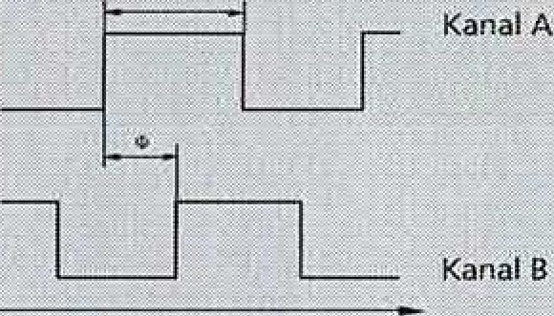

Drehrick-itung

Permissible deviation of the phase shift Ail,=190' - 180° H5°

**Output signals**

seen on downforce during rechis run

V CO

Kane! A/8

GNID

**shadow diagram**

- Fin additional external

Resistor can be added to increase the slope. Caution: low*max.*15 mA must not be exceeded

**Pin assignment**

Engine- .Z Mawr-, 050

41 V.5

5 channel

6 Kanai A

PVC-Flaalllarid cable

fr a11rla - 4.4S rr, m•

6.1

Lso

12.2_

6 4 2 5 3 1

Connector plug DIN-41651

Pitch 3 2.54mm

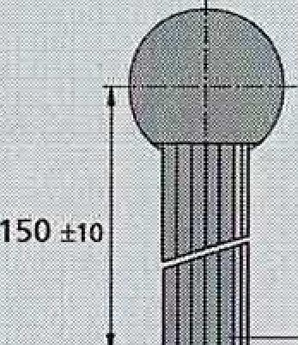

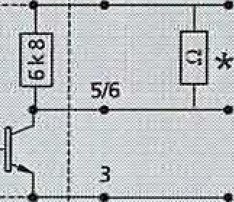

-O  
B

© by Dr.-Ing. Paul Christiani GmbH & Co. KG 25

|  |  |  |
| --- | --- | --- |
| Forfurther terhnicalFor explanations see “Technical Information. | **1?3** | Subject to change |

**FAULHABER**

Technical documentation Handling device

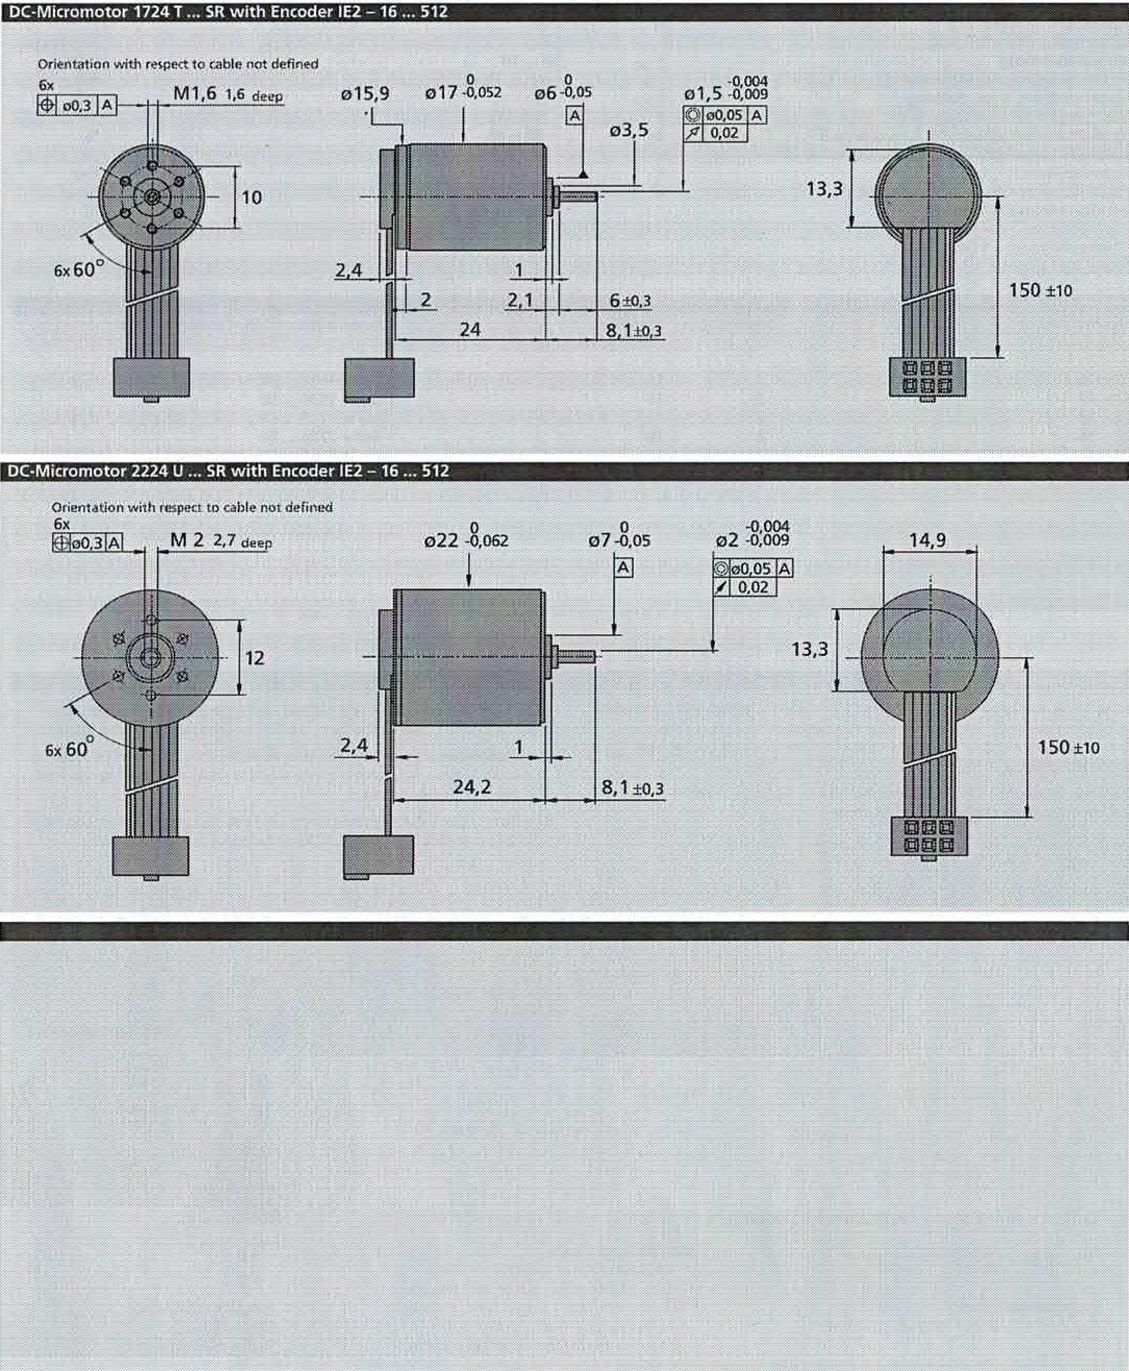

**DC micromotor 1724 T ... SR with encoder 1E2 —16 512**

Orientation with respect to cable not defined6x **M1.61.6**deep

10

**-0004**

01.50.009

o0.05 1A 0.02I

13.3

150 ±10

**DC•Micromotor 2224 U SR with Encoder 1E2 -16 — 512**

**0**o7-0.05

o22-0.062

150 °C

2.4

24.2

8.1 ±0.3

Orientation with respect to cable not defined

6x

M22.7deep

6x60

-0.004o2-0.009

)00.05AJ

/ 0.02

13.3

Fornotes**on technical data refer to 'Technical Information" Specifications subject to change without notice**

26

CO by Dr.-Ing. Paul Christian' GmbH & Co. KG

**126**

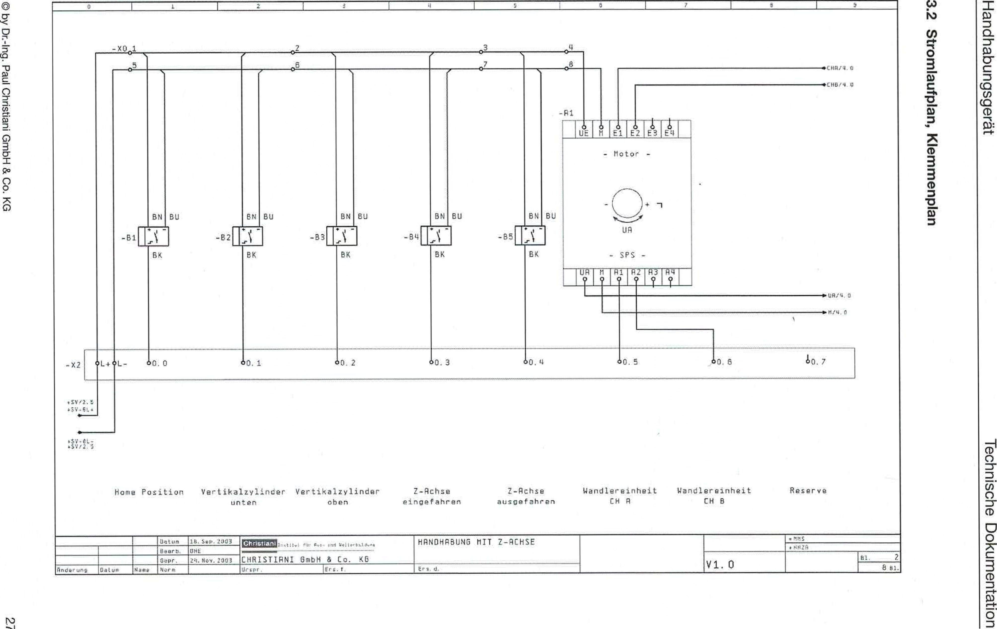

0)1 "00'8 HquJO tuellsi-ILIO Ined '6u1-%10 Aq ©

**3.2 Circuit diagram, terminal diagram**

lion6s6unqeqpueH

uopluawmp❑ agosiut.pal

-X001

BI

5

EN

BK

BU

-B2

EN

BK

EU

-53

EN

BK

EU

-BR

EN

EX

EU

-55

EN

BK

BU

-Al

UE[MElT,2TA[E1/41

**CRH/q.fl**

CHU

**U.**

**AVV4A**

_x2 CIL+

,L- 10.0

10.

0.5

4sve2.a  
,Fy-044

.sv-EL­45Yr.2.

|  |  |  |  |  |  |  |  |  |  |  |  |  |  |  |  |
| --- | --- | --- | --- | --- | --- | --- | --- | --- | --- | --- | --- | --- | --- | --- | --- |
| home position Vertical cylinder  untoward | | | | | Vertical cylinder open | Z-axis | |  | Z-axis Wall unit  extended CH R | | converter unit reserve  CH | | |  |  |
|  | | **Utton** | ="", |  | GmbH B Co. KG |  | HANOHABUN5 | WITH | 2—DEER |  |  |  |  |  |  |
|  |  | Bonn, | 0,q, | CHRISTUNI | .or:H2Fi |  |  |
|  |  |  | Nov. Zga3 | . |  | El | 2 |
| And,**uh,** | **DateU. 1,44Rit** | standard |  | Urcpr | Replacement 1 |  | Itd |  |  |  | btu. |

- Engine -

UA

PLC-

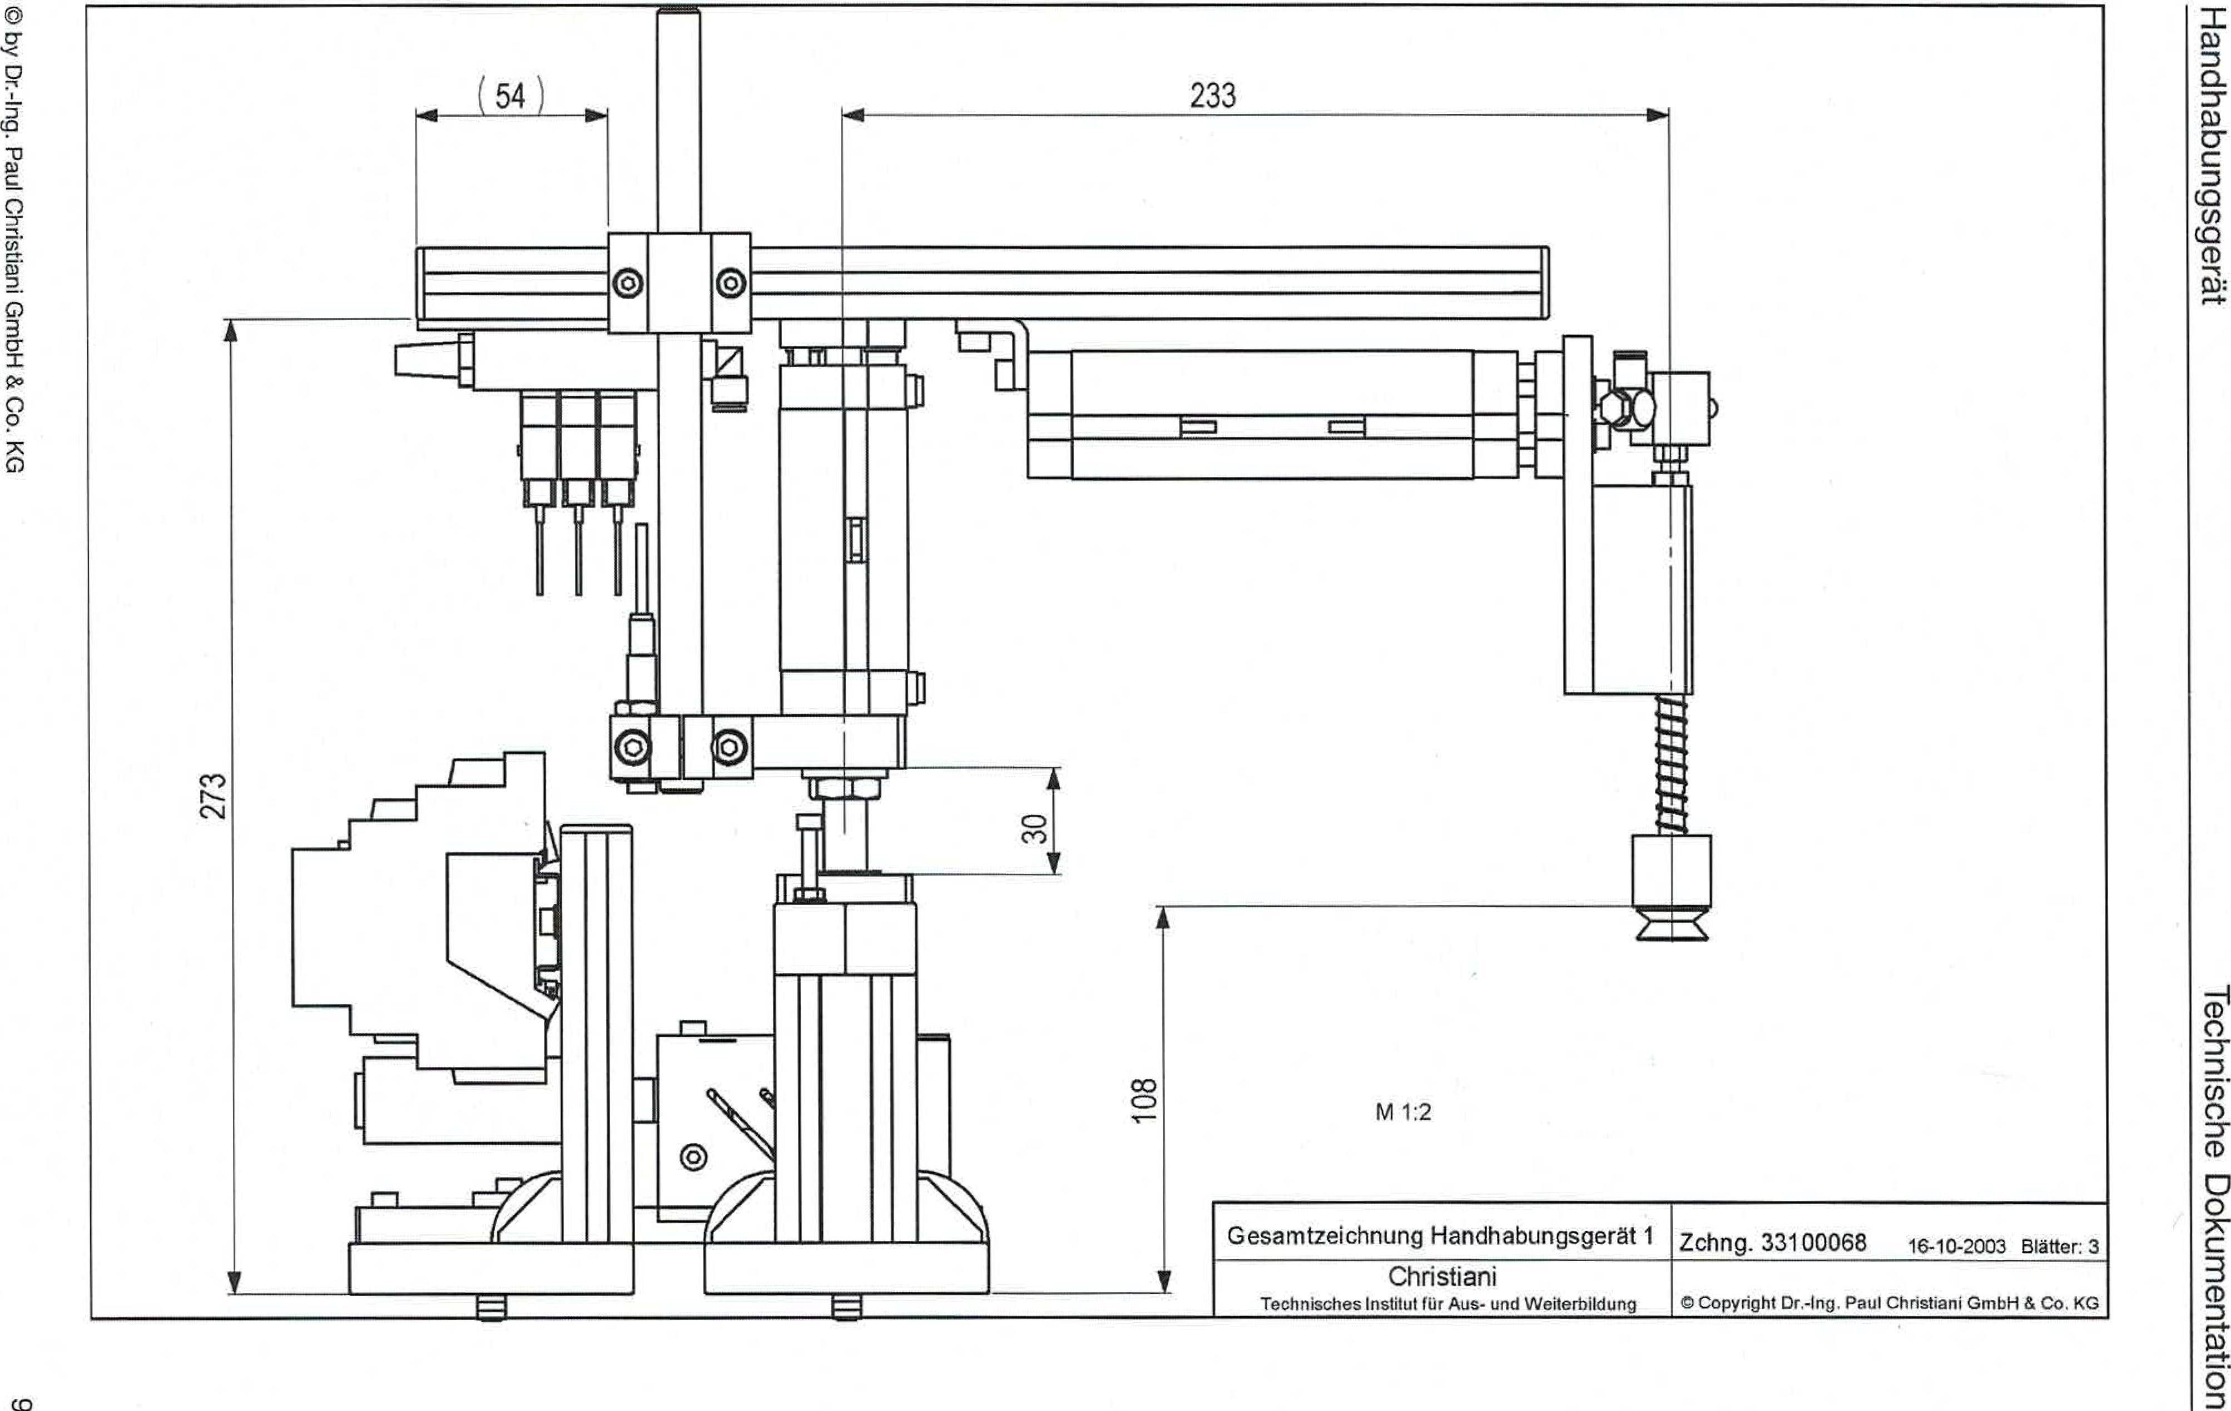

by Dr.-Ing. Paul Christiani GmbH & Co. KG

1?Aa6sbunqeqpueH

uo!luquewmioci agosiugal

4

233

**No-**

Scale 1:2

General drawing of handling device

Drawing.33100068 16-10-2003 & 3

A

Christiani

Technical Institute for Education and Training

© Copyright Dr.-Ing. Paul Christiani GmbH & Co. KG

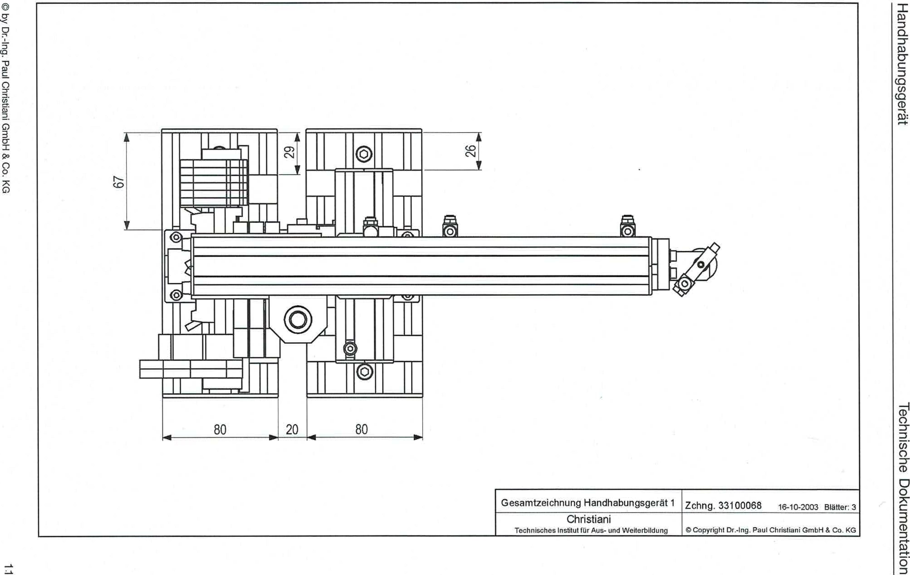

CO by Dr.-Ing. Paul Christiani GmbH & Co. KG

T?JeBsbunqeqpuSH

uopluewmiao apppyoal

rw

V

16-10-2003 Blatter: 3

General drawing of the land use device 1 drawing 33100068

71

Christiani

Technical Institute for Training and Further Education

Copyright Dr.-Ing. Paul Christiani GmbH & Co KG

**1.3 Total stack list**

Handling device Technical documentation

0 by Dr.-Ing. Paul Christiani GmbH & Co. KG

1.3

|  |  |  |  |
| --- | --- | --- | --- |
| **Item No.I Number I component**  **I NI%** | | | |
| 01.00 Axle handling kit (33100069) | | | |
| 01.01 | 2 | AI-Prof11 40/20x75 | 34053304_0075 |
| 01.02 | 4 | Cover cap 80x14 black | 34053030 |
| 01.03 | 8 | Angle 20x20 W6 | 34053003 |
| 01.04 | 8 | Angle cover cap 20x20 | 34053004 |
| 01.05 | 4 | T-slot nut M4 NU5 steel | 34053297 |
| 01.06 | 16 | Cylinder head screw ISO 4762- M4x8 - 8.8 | 35100000 |
| 01.07 | 12 | Hammer nut M4 NU6 | 34053006 |
| 01.08 | 1 | Shaft d=12 I=146 | 36100095 |
| 01.09 | 1 | Bevel gear z=30 m=1.5 | 36053080 |
| 01.10 | 1 | Threaded pin DIN 913 - M5x5 - 45H | 35100008 |
| 01.11 | 1 | Hexagon nut ISO 4035 - M12 - 8 | 35100029 |
| 01.12 | 1 | Disc DIN 125 - A13 - 140HV-A2 | 35100034  _ |
| 01.13 | 1 | Disc DIN 125 -. A 4.3 - 140HV-A2 | 35100004 |
| 01.14 | 1 | Hexagon nut ISO 4032 - M4 - 8 | 35100033 |
| 01.15 | 1 | Bund bach PCMF d=12 D=14 B=17 | 35100045 |
| 01.16 | 1 | Adjusting ring DIN 705-Al2 d= 12 D=22 B= 12 | 34051977 |
| 01.17 | 1 | T-slot nut M4 NU6 steel | 34053319 |
| 01.18 | 1 | Cylinder head screw ISO 4762 - M4x25 - 8.8 | 35100050 |
| 01.19 | 1 | Bearing for axle | 36100123 |
| 02.00 Axle bearing kit (33100123) | | | |
| 02.01 | 1 | Al profile 40/20x130 (34053304) | 36100100 |
| 02.02 | 1 | Edition | 36100112 |
| 02.03 | 4 | Cylinder head screw ISO 4762 - M4x8 - 8.8 | 35100000 |
| 02.04 | 4 | T-slot nut M4 NU6 | 34053319 |

Technical documentation Handling device

14

© by Dr.-Ing. Paul Christiani GmbH & Co. KG

|  |  |  |  |
| --- | --- | --- | --- |
| 03.00 Kit upper part with Z-axis (36100072) | | | |
| 03.01 | 1 | axle flange | 36100101 |
| 03.02 | 1 | Cylinder D=20 Stroke=60 | 34053092 |
| 03.03 | 6 | Cylinder head screw ISO 4762- M5x20 - 8.8 | 35100036 |
| 03_04 | 1 | Shaft bracket 12 | 34053082 |
| 03.05 | 1 | Cylinder head screw ISO 4762- M5x12 - 8.8 | 35100037 |
| 03.06 | 1 | Al profile 40/20x315 (34053304) | 36100179 |
| 03.07 | 4 | T-slot nut M5 NU6 | 34053096 |
| 03.08 | 2 | Cylinder head screw ISO 4762- M5x14 - 8.8 | 35100063 |
| 03.09 | 1 | Linear bearing D= 12 (34053081) | 36100178 |
| 03.10 | 2 | Cylinder head screw ISO 4762 - M4x20 - 8.8 | 35100039 |
| 03.11 | 2 | Hammer nut M4 NU6 | 34053006 |
| 03.12 | 1 | Shaft d=121=220 | 36100073 |
| 03.13 | 4 | Throttle check valve M5 exhaust air throttled | 34053060 |
| 03.14 | 4 | Cylinder switch 20160 | 34053094 |
| 03.15 | 2 | Cover cap 20x20 (34053030) | 36100180 |
| 03.16 | 1 | Inductive sensor IE 5121 M8x1 | 34053135 |
| 03.17 | 2 | Hexagon nut ISO 8675- M8x1 for sensor | 34053135_001 |
| 03.18 | 2 | Washer DIN 125-A 5.3- 140HV-A2 | 35100041 |
| 03.19 | 1 | Cylinder D=20 Stroke=100 | 34053141 |
| 03.20 | 1 | Mounting bracket for cylinder D= 20 | 34053093 |
| 03.21 | 1 | Cover cap 20x20 (34053030) | 36100183 |
| 03.22 | 2 | Cylinder head screw ISO 4762- M5x8 - 8.8 | 35100064 |
| 03.23 | 1 | Cover cap 20x20 (34053030) | 36100182 |
| 03.24 | 1 | Cover cap 20x20 (34053030) | 36100181 |

Handling device Technical documentation

© by Dr.-Ing. Paul Christiani GmbH & Co. KG

1.5

|  |  |  |  |
| --- | --- | --- | --- |
| **04.00 Suction cup kit with mounting (36100076)**  **,** | | | |
| 04.01 | 1 | Holder Mr. Sauger | 36100105 |
| 04.02 | 1 | Pipe | 36100106 |
| 04.03 | 1 | Suction cup holder | 36100108 |
| 04.04 | 2 | Cylinder head screw ISO 4762- M4x12 - 8.8 | 35100013 |
| 04.05 | 1 | Ejector | 34053163 |
| 04.06 | 1 | Compression spring DIN 2098 0.63x8x80.5 if 12.5 | 35100048 |
| 04.07 | 1 | Shaft screw ISO 2341 - M3x6 - 5.8 | 35100032 |
| 04.08 | 1 | Connection M5 | 36100124 |
| 04.09 | **1** | Hexagon nut ISO 4032 - M5 - 8 | 35100043 |
| 04.10 | 2 | Washer DIN 125 - A 4.3 - 140HV-A2 | 35100004 |
| 04.11 | 1 | Angle swivel fitting M5 | 34053328 |
| 04.12 | 1 | Suction cup with nipple M5 | 34053166 |
| **05.00 Base plate kit 80/14x180 (2x) (33100030)** | | | |
| 05.01 | 1 | Grooved plate 80/14x180 (34053295) | 36100038 |
| 05.02 | 2 | Cover cap 80x14 black | 34053296 |
| 05.03 | 2 | Hammer nut M6 NLI8 | 34053028 |
| 05.04 | 2 | Cylinder head screw DIN 7984 - M6x16 - 8.8 | 35100028 |
| **06.00 Valve island kit for 3 connections (3310064)** | | | |
| 06.01 | 1 | Connection point 3x | 36053061 |
| 06.02 | 2  _ | Silencer G1/8"  . | 34053062 |
| 06.03 | 3 | Locking screw G1/8" | 34053063 |
| 06.04 | 1 | Hose connection 90° D= 4mm G1/8" | 34060498 |
| 06.05 | 1 | Base plate for valve island | 36100104 |
| 06.06 | 6 | Countersunk screw ISO 10 642 - M4x8 - 8.8 | 35100031 |
| 06.07 | 2 | Hammer nut M4 NIA | 34053006 |

Technical documentation Handling device

16

© by Dr.-Ing. Paul Christiani GmbH & Co. KG

|  |  |  |  |
| --- | --- | --- | --- |
| **07.00 Pneumatic directional control valve kit (2x) (33100075)** | | | |
| 07.01 | 1 | 5/2 way valve 1x24V DC connection M5 spring return | 34053099 |
| 07.02  . | 1 | Device connector for directional control valve with cable | 34053065 |
| 07.03 | 1 | Hose connection 4mm M5 | 34053089 |
| **08.00** | **Pneumatic 5/2-way valve kit with accessories (33100077)** | | 34053099 |
| 08.01 | 1 | 5/2 way valve 1x24V DC connection M5 spring return |
| 08.02 | 1 | Device plug fC.ir directional control valve with cable | 34053065 |
| 08.03 | 1 | Hose connection 4mm M5 | 34053089 |
| 08.04 | 1 | M5 screw plug with seal | 34053043 |
| **09.00 Electrical transfer unit kit (33100073)** | | | |
| 09.01 | 1 | Top hat rail TS35 L= 170 | 34053325_0170 |
| 09.02 | 6 | Cylinder head screw ISO 4762 - M4x8 - 8.8 | 35100000 |
| 09.03 | 2 | Washer DIN 125 - A 4.3 - 140HV-A2 | 35100004 |
| 09.04 | 4 | Hammer nut M4 NU6 | 34053006 |
| 09.05 | 2 | Input and output module I 8 | 34053290 |
| 09.06 | 2 | Coupling relay 6.2mm, 6A, 24V | 34053287 |
| 09.07 | 2 | End angle | 34060000 |
| 09.08 | 2 | AI profile 20x20x115 | 34053286_0115 |
| 09.09 | 1 | converter unit | 34056426 |
| 09.10 | 1 | End separation plate WAP 2.5 | 34060806 |
| 09.11 | 6 | Terminal block WDU 2.5 | 34060475 |
| 09.12 | 1 | Wiring kit FKB mMS | 34053388 |
| 09.13 | 2 | Cover cap 20x20 | 34053030 |
| 09.14 | 2 | Angle 20x20 NU6 | 34053003 |
| 09.15 | 2 | T-slot nut M4 NU5 steel | 34053297 |
| 09.16 | 2 | Angle cover cap 20x20 | 34053004 |

Handling device Technical documentation

0 by Dr.-Ing. Paul Christiani GmbH & Co. KG

1.7

|  |  |  |  |
| --- | --- | --- | --- |
| **10.00 Kit drive motor with encoder (33100071** | | |  |
| 10.01 | 1 | Gear motor 24V with encoder | 34053306 |
| 10.02 | 1 | angle | 36100096 |
| 10.03 | 3 | Cylinder head screw ISO 7984 - M3x10 - 8.8 | 35100035 |
| 10.04 | 4 | Cylinder head screw LSO 4762 - M4x10 - 8.8 | 35100003 |
| 10.05 | 1 | Bevel gear z=15 m1.5 | 36053098 |
| 10.06 | 2 | Threaded pin DIN 913 - M5x5 - 45H | 35100008 |
| 10.07 | 1 | Adapter Mr bevel gear D= 6 | 36100111 |
| 10.08 | 1 | mounting plate | 36100098 |
| 10.09 | 1 | bearing block | 36100099 |
| 10.10 | 2 | PCMF flanged box d= 6 D= 8 B=8 | 35100046 |
| 10.11 | 1 | Flange socket PCMF d= 8 D= 10 B=9.5 | 35100047 |
| 10.12 | 8 | Cylinder head screw ISO 4762 - M4x16 - 8.8 | 35100001 |
| 10.13 | 8 | T-slot nut M4 NL15 steel | 34053297 |
| 10.14 | 1 | cover plate | 36100107 |
| 10.15 | 4 | Cylinder head screw ISO 4762- M4x6 - 8.8 | 35100018 |
| 10.16 | 1 | Cylinder head screw ISO 4762- M3x6 - 8.8 | 35100016 |
| 10.17 | 1 | Hexagon nut ISO 4032 - M3 - 8 | 35100017 |

**1B3** B2

B

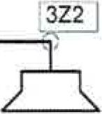

E

2

© by Dr.-Ing. Paul Christiani GmbH & Co. KG

1

AularrallanS

Lijal

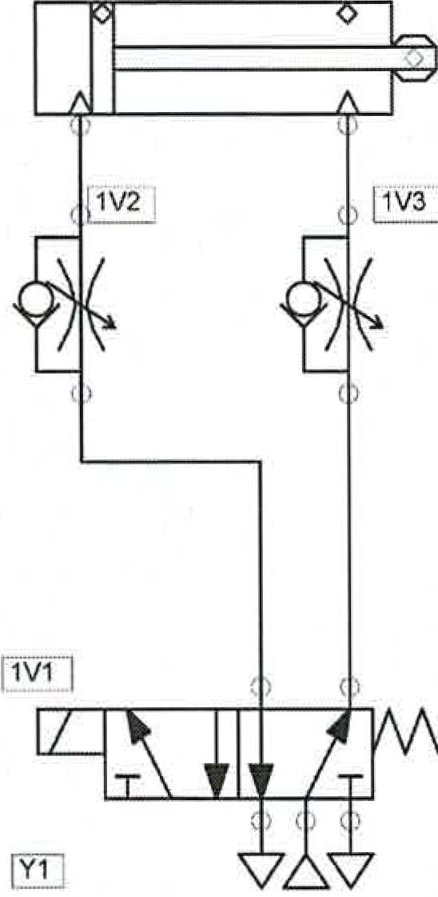

**1B4 1 T35—**

2A1

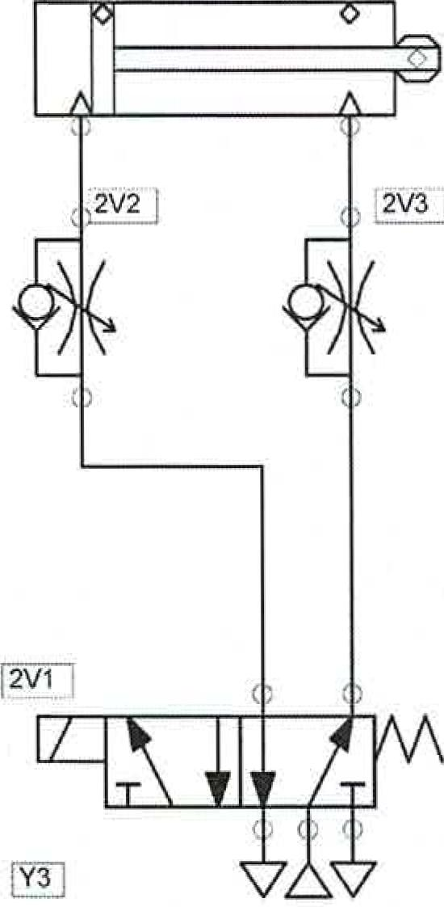

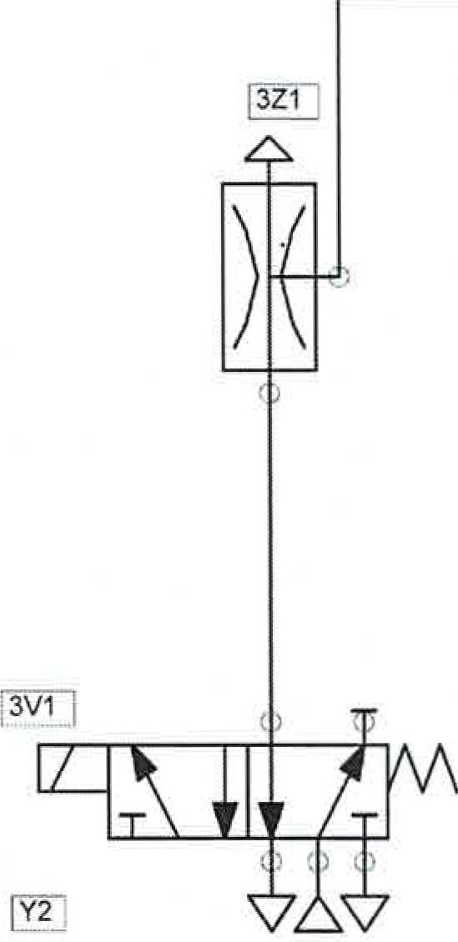

Handling system

1.1a6sbungeLipuSH

**ueldviewneud**

**viewneud-3**

uopluawmp❑ egospqoal

geZerfrnfl..11 Lay

*porunquIch* Lorenzen

sch.pwn [631°"'4""'05.10.2001**14:00:29**

E-pneumaticsCircuit diagram "h..0.6e1.29.11.200314:11:20Dr.-Ing. Paul Christiani **Number.**

B A

**3 Electrics**

Handling device Technical documentation

© by Dr.-Ing. Paul Christiani GmbH & Co. KG

21

**3.1 Data sheets**

**Christiani**

Tuchnisches Institute for Training and Further Education

**Data sheet converter unit**

|  |  |  |
| --- | --- | --- |
|  | **Christiani** | converter unitFinished module  Item no.: 56426 TTL/CMOS -> 24V Sn. no.: 00100 |
| **Technical Institute for Training and Further Education** | |

The converter unit is a DIN rail-mounted module. The module can be mounted directly on a DIN rail without the need for additional mounting hardware. It is used to power a motor and retransmit encoder signals to a programmable logic controller.

**Functional description:**

The converter unit is supplied with 24VdcAt the same time, the converter unit supplies the motor with its operating voltage. The motor is connected to a rotary encoder, which in turn transmits the signals to the converter unit. In the converter unit, the encoder signals are converted to PLC-compatible levels. The PLC records the converted encoder signals and determines the travel distance or the number of revolutions of the motor.

The converter unit also serves to control the speed of the motor. This is achieved by adjusting the operating voltage of the motor.

**Features:**

The input voltage Uesupplies the entire converter unit.**U,**1st always 24VDC, The converter unit includes two separate functions:

Voltage converter

The input voltage Ueis adjusted by means of an adjustable linear regulator to**U,**The output voltage U can be adjusted via a potentiometer. A voltage range between approximately 5VdC+1-10% and 17Vdc+/-10% is possible.

The output voltage U controls the speed of the connected motor.

Level conversion

A driver module from Allegro (module 1C2;UDN2987A) serves as an interface for converting standard low-level logic signals to PLC-compatible signals. This**TTL***(5VDC) and CMOS*(12VDC) Logic level in 24VdCLevel conversion. With this level conversion, for example,**TTL**Signals are connected to a programmable logic controller (PLC).

All unused entrances**(E1**to E4) should be connected to ground.

The exits (A1untilA4)The converter unit's outputs are short-circuit-proof. In the event of a short-circuited output, the converter unit or the entire system must be switched off, the short circuit must then be rectified, the connections checked again, and then put back into operation. Outputs that were briefly in a short-circuit state will only be reactivated after the converter unit is switched off and on again.

**Christiani**

**Technical Institute**for  
**Aims-And further training**

Technical documentation Handling device

**Data sheet converter unit**

**Technical data**

|  |  |  |
| --- | --- | --- |
| Designation | Abbreviation | Value |
| Supply voltage | LJ**e**  **11**mass | **24Vdc**  0 *DC* |
| Output voltage  Adjustable on the front panel using**R9** | U, | 5VDChis 17Vdc**10%** |
| Output current | **la** | **0 ...**50mA |
| Input can | E1...**E4** | **OVdC**  **5Vdc/**12Vdc TTL / CMOS |
| Output channels | **Al—.A4** | **0Vdc 24VDE** |

**Pin assignment**

22 0 by ❑r.-Ing. Paul Christiani GmbH & Co. KG

**UA** Output voltage 5V .. 17V

1 Ground (GND)

El..E4 Inputs 1..4

Setting of**UA**

Al ..A4 Outputs Al ..A4

1 Ground (GND)

**UE** Input voltage 24V

|  |  |  |
| --- | --- | --- |
| **UA** | **1** | **E4** |
| **El** | **E2** | **E3** |
| **- Engine -** | | |
| r. | | |
| A | | |
| **- PLC** | | |
| **Al** | **A2** | **A3** |
| **UE** | **1** | **A4** |